RESUME  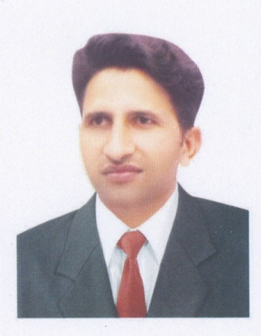  RAMZAN  ASSTANT MANAGER - GRAPHIC DESIGNER  Address: Sharjah, U.A.E.  Email: Ramzan.374108@2freemail.com  PERSONAL INFORMATION  D.O.B :13 Dec -1990  Gender :Male  Nationality :Pakistan  Religion :Islam  Marital status :Single  Languages :English ,Urdu, Punjabi  Driving License :In Process, after I'm taking  own car soon  PASSPORT DETAILS  Passport no : CA 9211551  Date of issue : 09/09/2014  Place of issue : Lahore  Expiry date : 08/09/2019  Visa status : Employment  Profession : Graphic Designer  CURRENT STATUS;  Position: Assis. Manager & Graphic designer  Location: Sharjah- U.A.E.  Salary expectation : AED 5000-6000 and Accommodation | OBJECTIVE  My objective is to work daily gently to use my full potential to the better interest of the concern and use my full talents and experience in Creativity, drawings with a good base of build a good carrier, able to assume full responsibilities and undertaking challenging job with enthusiasm and interest and it will be highly appreciated if you will give me an opportunity to prove my excellence and talents in your esteemed presence.  WORK EXPIRERNCE  - Currently I'm working in a printing company as a assistant manager plus graphic design in Sharjah, U.A.E. for two year seven months.  - I've four year three months worked as a graphic designer in a (telenor) telecom company in Lahore Pakistan.  - I can make video & photo graphic & editing also.  - Digital & offset printing machines operating.  - I'm making designs of company profiles, flayers, brochure, magazines, product packaging, exhibitions, corporate identity,  business cards, pamphlets, DVD-CD stickers & covers, etc.  - Indoor, outdoor, sign board, flex board, Pena flex's etc. designs.  - All kind of bill book, receipt voucher, book covers, invoice & letter head etc.  - Making mug & tee shirt logo & designs.  - Making Auto CAD Plotting.  - I've good ideas for every kind of art work.  - Excellent in creative designs & customer motivation.  - Under pressure & team working.  - I'm operating machines Konica Minolta, Cannon, Oce, Xerox, HP,  K Jet, Designer Jet  EDUCATIONAL QUALIFICATION  Master Degree (Pending) 2015 / 2016 PU Lhr. Pakistan  B.A Graduation 2013 PU Lhr. Pakistan  I Com 2011 B.I.S.E Lhr.  Matriculation 2009 B.I.S.E Lhr.  TECHNICAL QUALIFICATION  Computer diploma for graphic designing.  Adobe Illustrator, Adobe Photoshop, Corel Draw, Ms Office, Urdu In Page, Internet, Ms Access. Installation of Operating Systems Software and Windows. Typing English, Arabic & Urdu.  KEY STRENGTH  - Communicating: Communication skills.  - Quick learner.  - Self motivated  - Punctuality  - Team work skills  - Customer service skills  - Good team worker and able to work under pressure  HOBBIES /EXTRA-CURRICULAR ACTIVITIES  - Playing Football  - Playing cricket  - Swimming  - Reading news  DECLARATION  The information furnished above is true to the best of my knowledge and belief.  Ramzan

