MAR ANTHONY

Abu Dhabi, UAE

Maranthony.374113@2freemail.com

Carrier Objective

A competent Electrical Engineer with 7 years’ experience in this field seeking for a job in a growth oriented company. Has a good technical knowledge in Electrical Design Principles and familiar with execution of project at site.

Areas of Interest

- Construction Engineering and Design Development

- Electrical Utilities and Maintenance

- Power Production and Distribution

- Oil and Gas Engineering

- Engineering Services

Personal Data

PROFILE: Male, 30, Married

NATIONALITY: Filipino

PERMANENT ADDRESS: Mangaldan, Pangasinan, Philippines

NOTICE PERIOD: Can Start Immediately

VISA TYPE: Visit Visa

EXPECTED SALARY: Negotiable

Professional Experience

ELECTRICAL ENGINEER
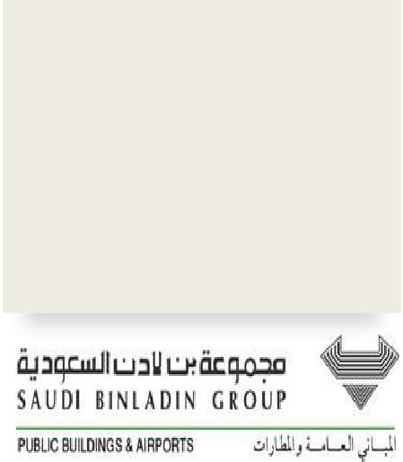

Saudi Binladin Group-Public Building & Airport Division (SBG-PBAD) Jeddah, Saudi Arabia

SEPT 2010 – SEPT 2016

(6 years & 1 month)

- Provide leadership to the assigned task in preparing Electrical Shop Drawings and develop detailed drawings as per the contract/projects specification prior for submission to the consultant in order to execute site works deadline.

  - Lighting, Power, Cable Routing, and Low Current Layout (external/internal) using AutoCAD and REVIT (BIM) for coordination.

- Check, review, and modify shop drawings prepared by team and sub-contractors by applying knowledge of electrical principles and as per clients’ requirements.

- Manage and monitor the performance of subordinate staffs.

- Do the computations such as sizing Transformers, Generators, Cables, UPS Rating and its overcurrent protection devices (Breaker, Fuse, and Switch) and necessary requirements for electrical system.

- Prepare, review, and modify Single Line Diagram of Electrical System (MV / LV system).

- Perform Load Calculation (Panel Board Schedule, Load Analysis, Voltage Drop, Short Circuit and carry out related engineering calculation

- Review and answer RFI’s, letters, and design queries during the project construction.

- Participate in value engineering for reduction (optimization) of construction cost while maintaining the functionality of the related project.

- Contribute technical support in various stages of project including conceptual design and design development in execution of projects as a team.

- Review of large scale engineering plans, designs, specification and verify BOQ for tendering and bidding purposes.

- Take of the quantity and prepare preliminary BOQ

Page 1 of 3

- Projects Involvement

  - Al Shumaisi Project (Jeddah, Saudi Arabia) – 2010 to 2013

    - An emergency lodging/ deportation center project by Saudi government approximately 2 x 1.2 km Area with 2.4 billion SAR budget allocated. It consists of more than 200 bldgs. Including detention, administration, hospital, central kitchen, laundry buildings, and substation and data centers.

    - I’m part of a team assigned by Electrical Section Head who monitors the daily activities of a given task and preparing the loading and distribution for a given Building Loads. Accomplished to do the LV and MV SLD for a given project.

  - Al Shamiya Service Building (Mecca, Saudi Arabia) – 2013 to 2015

    - An expansion project by Saudi government to Haram Mosque to accommodate the capacity of Muslim pilgrimages.

    - The project was divided into 4 Zones and each zone was given to Team led by Section Head. Assisted section head in responsibility to do the required electrical shop drawings.

  - KAEC Street Lighting (Rabigh, Saudi Arabia) - 2014

    - Team leader of 7 km long street lighting projects accomplished by my team.

  - Madinah Haram Expansion (Madinah, Saudi Arabia) – 2014 to 2015

    - Another expansion project by Saudi government to Haram Mosque to accommodate the capacity of Muslim pilgrimages.

    - Designated as part of a team responsible to do the required electrical shop drawings.

  - Ibrahim Nassir International Airport Expansion (Maldives) - 2015
    - Construction of New Terminal Building with 3 additional gates.

    - Administered in developing the conceptual design. Submitted proposals for approval of the client.

  - King Faisal Specialist Hospital & Research Centre (Jeddah, Saudi Arabia) - 2014-2016

    - Ongoing construction of New Medical City approximately 1000 beds capacity including administration, research and academic buildings.

    - Working together with the team in the first stage of project construction.

PROJECT ENGINEER

Plug Electric Mfg. Corp.

(PEMCOR)
Parañaque, Philippines

NOV 2009 – AUG 2010

(10 months)

- Responsible in handling, implementation, supervision and completion of project at site works.

  - All electrical installation of electrical equipment such as Transformer, UPS, Panelboard, Cable Pulling, Cable Tray/Ladder, Lighting and Power Layout.

- Coordination with other contractors and suppliers. Present weekly progress reports and attend meetings with the clients.

- Handle emergency work on call, troubleshooting and organizing routine servicing schedules to the client.

- Preparing as built plans of finished projects such as electrical layout, single line diagram, riser diagram and all necessary electrical details.

- Testing and Commissioning for the projects done.

Education

MAPUA INSTITUTE OF TECHNOLOGY

Manila, Philippines

Bachelor of Science in Electrical Engineering

July 2003- Dec 2007

Page 2 of 3

MANGALDAN NATIONAL HIGH SCHOOL

Mangaldan, Pangasinan, Philippines

Secondary High School

June 1999- March 2003

Professional

Certificates

SAUDI COUNCIL OF ENGINEERS

Saudi Arabia (Sept 2013)

Membership No. 153737

REGISTERED ELECTRICAL ENGINEER

Professional Regulation Commission (Licensure Examination) Manila, Philippines (May 2009) Licensed No. 43097

IT Skills

• Window & Office Tools

Microsoft Office (Word, Excel, PowerPoint, Outlook, etc.) Advanced

Auto CAD Advanced

Revit (BIM) Intermediate

ETAP Basic

• Operating System, Networking & Hardware

Windows Program Installation Advanced

OS Troubleshooting Intermediate

Internet Browsing & Searching Advanced

Key Qualifications
• Excellent interpersonal and communication abilities and possess a wide range of technical skills.

• Well organized and highly efficient working in a multi-tasking, high pressure and challenging dynamic environment.

• Ability to plan, organizes, supervises the work of others and enjoys being a part of a team.

• Excellent in speaking English, can speak basic Arabic and a native of Filipino (Tagalog)

Page 3 of 3

