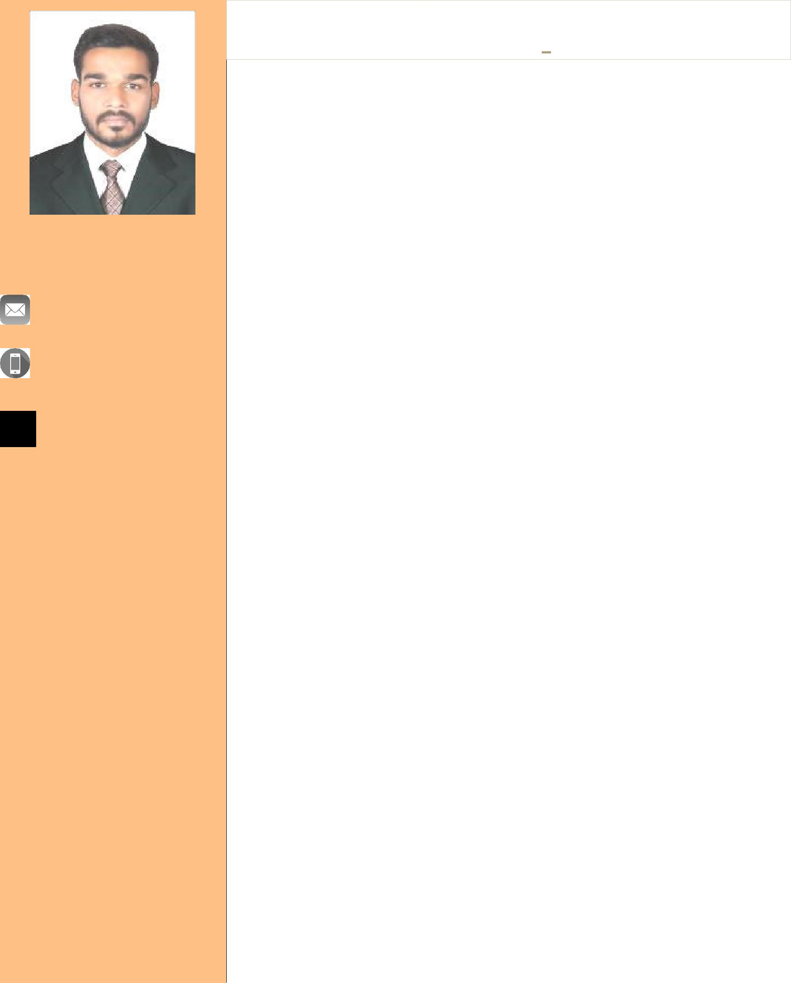

Nazim

Nazim.374118@2freemail.com

Rajasthan (India)

S T R E N G T H S

- Belief in hard work

- Flexibility

- Patience

I N T E R E S T S

- Basketball

- Volleyball
CURRICULUM VITAE

CAREER OBJECTIVE

To be a successful Travel & Tourism Industry Professional.

KNOWLEDGE AND WORK EXPERIENCE

  - Good Knowledge of Ticketing issuance and reissuance on 02 GDS (Amadeus and Galileo).

  - 01 year of experience with AJMERI TOURS & TRAVELS, Bhilwara (IN) as Senior Travel Consultant.
EDUCATIONAL QUALIFICATIONS

- B.A. Pursuing from Jain Vishav Bharati Institute, Ladnun, (RAJ).

- 12th Passed out from National Institute of Open Schooling, New Delhi
|2017

- 10th Passed out from Central Board of Secondary Examination,
New Delhi |2014

PROFESSIONAL QUALIFICATION

- Diploma in International Airlines & Travel Management from

leading Institute, International Institute Training Careers (IITC), New Delhi.

- Foundation In Travel And Tourism (IATA) from IATA Training And Development Institute (ITDI), Montreal Canada.

- CRS Training In Galileo & Amadeus.

LANGUAGE KNOWN |  |  |  |  | COMPUTER
• | English |  | Excellent |  | MS Office | Excellent
• | Hindi |  | Excellent |  | Adobe CS | Basic
ADDITONAL DETAILS:-
Date of Birth |  |  | : | 10Aug96
Marital status |  |  | : | Unmarried
Gender |  |  | : | Male
Nationality |  |  | : | Indian
Religion |  |  | : | Islam

