BIJU

Dubai, UAE

E-mail:

Biju.374128@2freemail.com

Educational Qualification

Diploma in

Engineering

Institute of
Engineering
Technology

Thrissur-Kerala.
(UAE Attested)

CARRICULUM VITAE
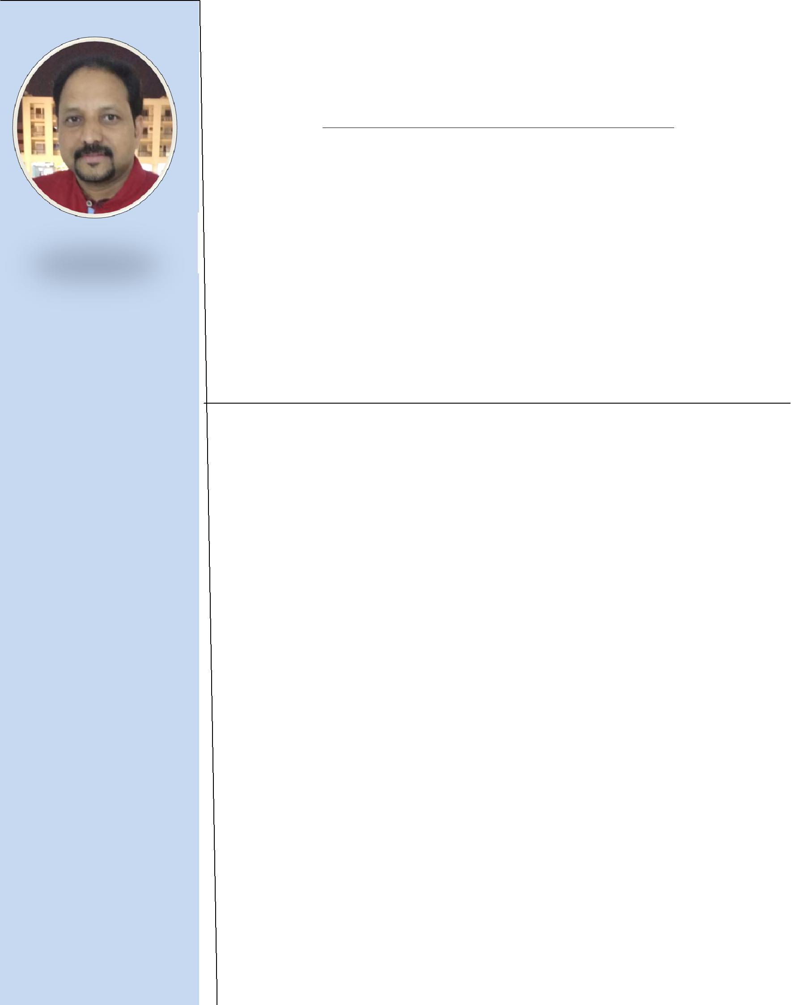

APPLICATION FOR MEP DRAUGHTSMAN

Auto CAD, Revit

CAREER OBJECTIVE

To work in a dynamic environment with growth potential where creativity, team spirit, hard work, dedication are highly appreciated, where I can utilize my professional skills.

SKILL SUMMARY

- 10 years experience as a MEP Draughtsman in -Gulf Countries

PROFESSIONAL EXPERIENCE

 | From 2016 April to 2017 June:- |  | 1). ARIF AND BINTOAK ARCHITECTS-
 |  |  | ENGINEERING CONSULTANT-DUBAI
 | Position |  | : Senior Mechanical Draughtsman
 |  |  | (Plumbing, Fire Fighting,)
Projects Handled |  |  | ✓ Mixed Use Building (3B+G+M+25+Roof)
 |  |  | Mankhool Dubai.
 |  |  | ✓ Aster Hospital Dubai & Sharjah.
 |  |  | ✓ Town House, ER Community Dubai land.
 |  |  | ✓ Al Guarair Investments, Residential Building
 |  |  | Dubai
 |  |  | ✓ Hotel service, Apartments-Marina Duabi.
 |  |  | ✓ Circle Mall al Barsha-Duabi
 | RESPONSIBILITIES:- |  | ➢ Schematic Design
 |  |  | ➢ Authorities submission
 |  |  | (Dubai Municipality, Civil Defense
 |  |  | DEWA, RTA)
 |  |  | ➢ Tender Submission
 |  |  | ➢ Contract Drawing submission.
 |  |  | ➢ MEP Coordination

 | Passport& Visa |  |  |  |  | From 2011 March to 2016 April:-
 | Details |  |  |  |  | Position
 | Passport No |  | : K 9345892
 |  |  |  |  |  | Projects Handled :
 | Place of Issue : Dubai
 | Visa Status |  | : Visit Visa
 | Visa Exp |  | :05-Jan -2018
 | Able to Join |  | :Immediately |  |  | From 2007 March to 2011 Jan
 |  |  |  |  |  | Position
 |  |  |  |  |  | Projects Handled:-
Personal Details |  |  |  |  |  | RESPONSIBILITIES:-
Date of Birth : 29-05-1972
Nationality |  |  | : Indian
Sex |  |  | : Male
Language
Known as |  |  | :English

: Hindi

STRENGTH:-
: Arabic

: Malayalam

DECLARATION:-

DUBAI

NOV-2017

2). EMIRATES TRADING AGENCY (ETA) DUBAI

- Senior Mechanical Draughtsman (Plumbing, Fire Fighting, HVAC)
  - Dubai International Airport-T3

  - Damac paramount Tower- Business bay

  - Cleveland Hospital –Abu Dhabi

3). QATAR ELECTRO MECHANICAL GROUP AL-MANA- QATAR

- MEP Draughtsman ( Plumbing)
- Business Park Qatar (Shopping mall)

- Perl Qatar

  - Preparing detailed shop drawings.

  - Co-ordination and section Details

  - Preparing of underground water main layout and trench piping.

  - Preparing of hot and cold water supply piping system include booster pump arrangement and it associated piping.

  - Preparing underground drainage layouts &calculating inverted levels.

  - Preparing shop drawings for manholes, Grease traps, lint interceptor etc

- Leadership, Problem solving, decision making

- Team Work and strong work Ethic…

  - I hereby declare that the above Mentioned details are true to the best of my knowledge and behalf.

Sincerely,

BIJU

