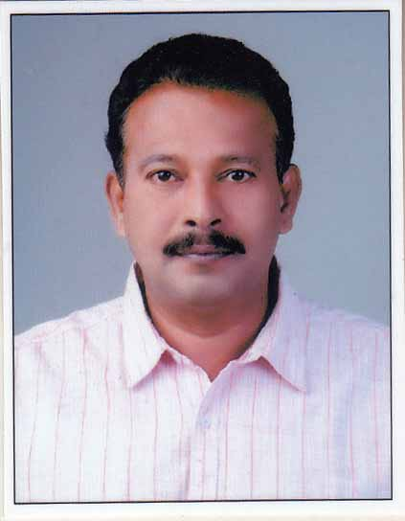

VIJAYAN

Email: vijayan.374172@2freemail.com

CONSTRUCTION PROJECT MANAGEMENTPROFESSIONAL

PROFILE SUMMARY
- A seasoned Civil Engineering professional with over 30 years of experience in:
~ Planning ~ Project Management ~ Construction Management
~ Site Management ~ Safety Management ~ Quality Management
~ Quantity Surveying ~ Liaison and Coordination ~ Manpower Management
- An astute & multi tasking leader with qualitative experience in formulating strategic plans; establishing entire project operations with key focus on profitability –High rise building Projects, Industrial Projects, Heavy Equipment Foundations, Effluent Treatment plants, Bio Gas Generation Plants & Coal based Thermal Power plants and Petrochemical Projects etc.
- Proficient in planning & executing construction projects involving method engineering/statement, contract administration and resource planning with a flair for adopting modern construction methodologies/techniques likeAuto CADD,Primavera, MS Projects etc.
- Hands-on experience in swiftly ramping up construction projects with competent cross-functional skills; ensuring on time deliverables within pre-set cost parameters
- Strong organizer, motivator, team player and a decisive leader with successful track record in directing from original concept through implementation to handle diverse market dynamics
- Possess exceptions communication, people management, leadership, problem solving, decision-making & interpersonal skills
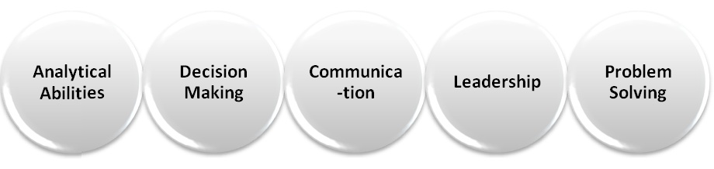
CORE COMPETENCIES
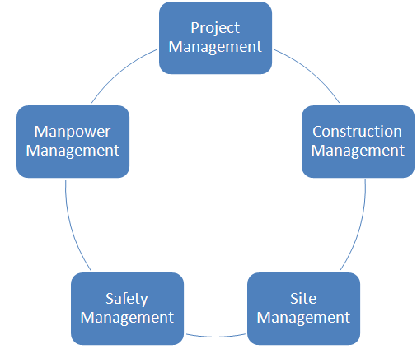
- Developing project baselines; monitoring and controlling projects with respect to cost, resource deployment, time over-runs and quality compliance to ensure satisfactory execution of projects
- Managing the construction process from the conceptual development stage through final construction, making sure that the project gets done on time and budget
- Spearheading a team of Engineers, Junior Engineers, Foremen, Surveyors and Supervisors with 300 numbers of skilled/unskilled labor in a day
- Overseeing the selection of contractors and consultants to complete specific pieces of the project
- Evaluating & determining appropriate construction delivery systems and most cost-effective plan / schedule for completing the project
- Anchoring on-site construction activities to ensure completion of project within the time & cost parameters and effective resource utilisation to maximise the output
- Inspecting field sites to observe and evaluate condition and operability of facilities and structures, and to collect field survey data and measurements
- Liaising with consultants, contractors, sub contractors & external agencies for determining technical specifications, approvals and obtaining clearances
- Reviewing designs, drawings, specifications, BOQ & modifications required to suit to prevailing site conditions, checking survey works with modern equipment
- Receiving of material indents from site, analyzing the requirement and submission for approvals

EMPLOYMENT DETAILS
Since 2005 to Present: M/S PRECISE CIVIL ENGINEERING PVT LTD

Sr.Project Manager– Tendering, Planning, Execution& Commissioning

- Spearheading efforts across managing& monitoring the overall project performance on regular basis & taking steps for further improvements with a view to complete project within stipulated time & budget.
- Managing overall project activities including project scheduling and resource allocation of men, material, machine and money to maximize operational efficiency; identifying key milestones and forecasting completion timeline.
- Maintaining coordination for with consultants in relating to concept designing of new stores. Explored newer materials/ technologies/ products and design innovations to provide best in class services.
- Instrumental in overlooking the finishing of the residential projects in line with the electrical, landscaping, plumbing, etc.
- Regularly coordinating with architects & contractors to identify and isolate project bottlenecks and clarify any ambiguities to accelerate project execution.
- Maintaining perfect coordination with the project team & all internal/external parties to freeze the technical parameters/ work scope to iron out any ambiguities; carrying out work measurements and providing technical validation for jobs.
- Efficiently liaising and coordinating with clients, consultants, architects and sub-contractors of the projects while ensuring profitability and project deliverables.
- Monitoring the overall project performance on regular basis & taking steps for further improvements with a view to complete project within stipulated time frame & prescribed budget.
- Strategically planning & controlling all project activities connected with safe and efficient operations; implementing quality standards for meeting the set targets within time & cost parameters.
- Judiciously supervising site activities including man and material management while providing technical inputs for methodologies of construction & maintenance.
- Designing and implementing stringent systems and quality plans / manuals to ensure high quality standards during all the stages of construction.
- Reviewing designs, drawings, specifications, BOQ & modifications required to suit to prevailing site conditions.
- Involving in all phases of project execution; approved engineering/design changes, troubleshot and resolved complex technical problems, consistently meeting project deadlines and highest possible quality standards.
- Drawing up project plans, schedule of activities, planned, procured, mobilized, and deployed resources to deliver the project within defined time and costliness.
- Pioneer in managing resources while creating estimates for the project, work breakdown structure, project plan, contingency plan & schedules, identifying risks within defined scope, quality, time and cost constraints.

Projects Handled

- CivilWorks- For Petrochemical Plant for JBF, Mangalore, Karnataka. 2015-2017

- Civil Works - For Ash Handling Plant In BAJAJ INFRASTRUCTURE DEVELOPMENT COMPANY LTD For their 3x660MW Super thermal Power Plant Project in Chiklawa, Mirchwada, Burogoan, Lalitpur, Uttar Pradesh, 2013 – 2015.
- Civil Works - For Ash Handling Plant& Chemical Laboratory, Side Stream Filter Pump House, Side Stream Filter Support Foundations Chemical House, Retention Pits, Neutralization Pits, ETP for 6x135MW Power plant In Power Plant Project - Jindal Steel & Power Ltd, Angul, Odisha, 2010 - 2013
- Civil Works- For Ash Handling plant Of 4*600 MW Power Plant Project For SEPCO III In Vedanta Aluminum Ltd,Jharsuguda, Odisha, 2008 – 2010
- Effluent Treatment Plant, Buildings, MBR plant & RO Plant For Ambur Development Authority Ltd in Thutthipeth, Vaniambadi & Ambur 2009 to 2010.
- Structural fabrication & erection forINDORAMA SYNTHETICS LTD at Butibori, Nagpur, Maharastra 2007 – 2008.
- Bio-gas Generation Cum E T P For U E M (I) Pvt Ltd On their Projects In A B Mouri (I) Pvt Ltd, MIDC, Lote, Parashuram, Khed, Ratnagiri, Maharashtra, 2006 – 2007
- Plant Expansion, Utility Building, yeast Extractor Building, Spray Dryer Building, Effluent Treatment Plant, R O Plant, Heavy Equipment Foundations, Pipe Rack Foundations Etc In A B Mouri (I) Pvt Ltd, MIDC, Lote Parashuram, Khed, Ratnagiri, Maharashtra , 2006 – 2008

M/S Precise Civil Engineering, 1995 – 2005
Chiplun,Ratnagiri,Maharashtra.

Project Manager, Sr. Manager, Manager

Projects
- Factory buildings In Filtra Catalysts & Chemicals Ltd & Vinathi Organics Ltd, MIDC, Lote Parashuram, Khed, Ratnagiri, Maharashtra.
- Construction of Marketing buildings (Basement + Ground + 5 floors Buildings) InPidilite Industries Ltd at Kondivitta, Andheri(E), Mumbai, Maharashtra – 40059.
- Town ship for Kesar Petro Products Ltd, at MIDC, Lote Parashuram, Khed, Ratnagiri, Maharashtra.
- Town ship for Gharda chemicals Ltd, at MIDC, Lote Parashuram, Khed, Ratnagiri, Maharashtra.
- Factory Buildings for Hindustan Lever Ltd, at MIDC, Lote Parashuram, Khed, Ratnagiri, Maharashtra.

M/S MH Khan & Associates, Mumbai1989 – 1995

Site in charge, Sr. Engineer

Projects
High rise buildings in Thane & Kalyan for Goderj Properties & Investments Ltd.
- Industrial buildings, RCC tanks, Equipment foundations, Pipe rack foundations and other civil jobs in Tata Vashisti Detergents Ltd, MIDC, Lote Parashuram, Khed, Ratnagiri, Maharashtra –
- Reactor foundations, Boiler foundations, Equipment Foundations, Boiler house and Related civil jobs in KESAR Petro Products Ltd, MIDC, Lote Parashuram, Khed, Ratnagiri, Maharashtra –
- Reactor foundations, Equipment foundations, Staff quarters buildings in Gharda Chemicals Ltd, MIDC, LoteParashuram, Khed, Ratnagiri, Maharashtra.

INITIAL EXPERIENCE
M/s SUPERB CONSTRUCTIONS,THANE, MUMBAI

Site Engineer 1985 to 1989

At their Projects for Modella woolens Ltd and JK Files & Tools at Mumbai &Chiplun, Maharashtra.

SCHOOL LEVEL EDUCATION
. Junior Technical School Leaving Certificate from JTS, Shoranur, Kerala- State Board of Technical Education, Kerala State in 1982 with 64.4% Marks

PROFESSIONAL QUALIFICATIONS

- Diploma in Civil Engineering from Seethi Sahib Memorial Polytechnic, Tirur, Kerala - Board of Technical education, Kerala State in 1985 with 74.66% Marks,

Certificate Courses & IT skills
- Diploma in Civil Auto Cad-2D &3D-Autodesk 2014
- Diploma in Primavera-Oracle-P6-8.3
- Diploma in MS Projects-2013
- Well versed with MS- Office(Word, Excel and Power Point) and Internet applications.

PERSONAL DETAILS
Date of Birth: 25thMay 1967
Marital Status: Married
Languages Known: Malayalam, Hindi, English, Tamil and Marathi.
Passport No: P9119285

Expected Salary: 17000 AED
Visa Status: Visiting- valid till 19-01-2018
Date of Joining: Immeadiate.

DECLARTION:

I HERE BY DECLARE THAT THE INFORMATION FURNISHED ABOVE IS TRUE TO THE BEST OF MY KNOWLEDGE

PLACE: ALAPPUZHA
Vijayan
Date: 04/11/2017

