Imran
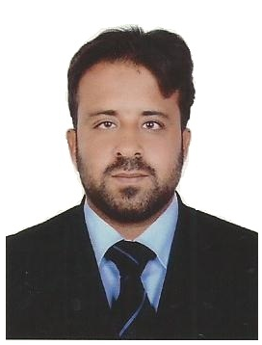
E-mail Imran.374183@2freemail.com
Add: AJMAN - UAE

PERSONAL SUMMARY
To work in a prestigious company with an environment which is mentally challenging and offers an opportunity for personal growth, where in I can impart my skills, abilities and knowledge obtained from previous work experiences.

CAREER HISTORY

Company: EXPO Marketing Group
Designation: Tele sales Team Leader
Period: From May 2015 to Sep 2017
Country – City: UAE – AJMAN
Key Responsibilities:
- Placed sales calls to current or inquiring customers
- Provided reports of all sales results including customer comment or complaints
- Attended meetings and read information regarding company services to remain fully educated
- Entered all customer information into company database keeping confidentiality in mind at all times
- Helped customers solve problems by changing or adding to their service.

Company: UPS (United Parcel Services- Courier Company)
Designation: Customer Services Representative
Period: From June 2013 to FEB 2015
Country – City: Pakistan – Sialkot
Key Responsibilities:
- Engaging in conversation with customers.
- Preparing invoices at the time of service and processing payment.
- Carrying out customer service assessments to identify and priorities needs.
Confirming orders placed by customers via the phone, post and internet.

Company: TCS (Courier Company)
Designation: Customer Services Representative
Period: From Dec 2009 March 2013
Country – City: Pakistan - Sialkot
Key Responsibilities:
- Answering customer questions regarding products / Services.
- Organizing the shipping of goods to customers.
- Listening out for and identifying opportunities to cross sell additional products and services.
- Logging information at computerized systems.
- Meeting and greeting customers in a friendly and timely manner.
- Engaging in conversation with customers.
- Preparing invoices at the time of service and processing payment.
- Carrying out customer service assessments to identify and priorities needs.
ACADEMIC QUALIFICATIONS

- Degree: B.COM (Bachelor of commerce) 2004
Institute: University of the Punjab (Lahore)
Country: Pakistan

- Diploma: D.Com (Diploma of Commerce) 2000
Institute: Punjab Board of Technical Education (Lahore)

- Certificate: Secondary School Certification 1998
Institute: Board of Intermediate & Secondary Education (Gujranwala)

IT Skills

- Microsoft Word
- Microsoft Excel
- Explorer and Internet Surfing
Personal
- Able to deal with frequent changes in the work environment.
- Willing to work additional hours if required.
- Available for weekends and evening work.
- An ability to organize and present information for a varied audience.
- Flexible with regards to work location.

Personal Information

Nationality: Pakistani
Date of birth: December 03, 1982
Visa Status: Own free zone visa
Passport Issue date: Nov, 2013
Passport Expiry date: Nov, 2018

