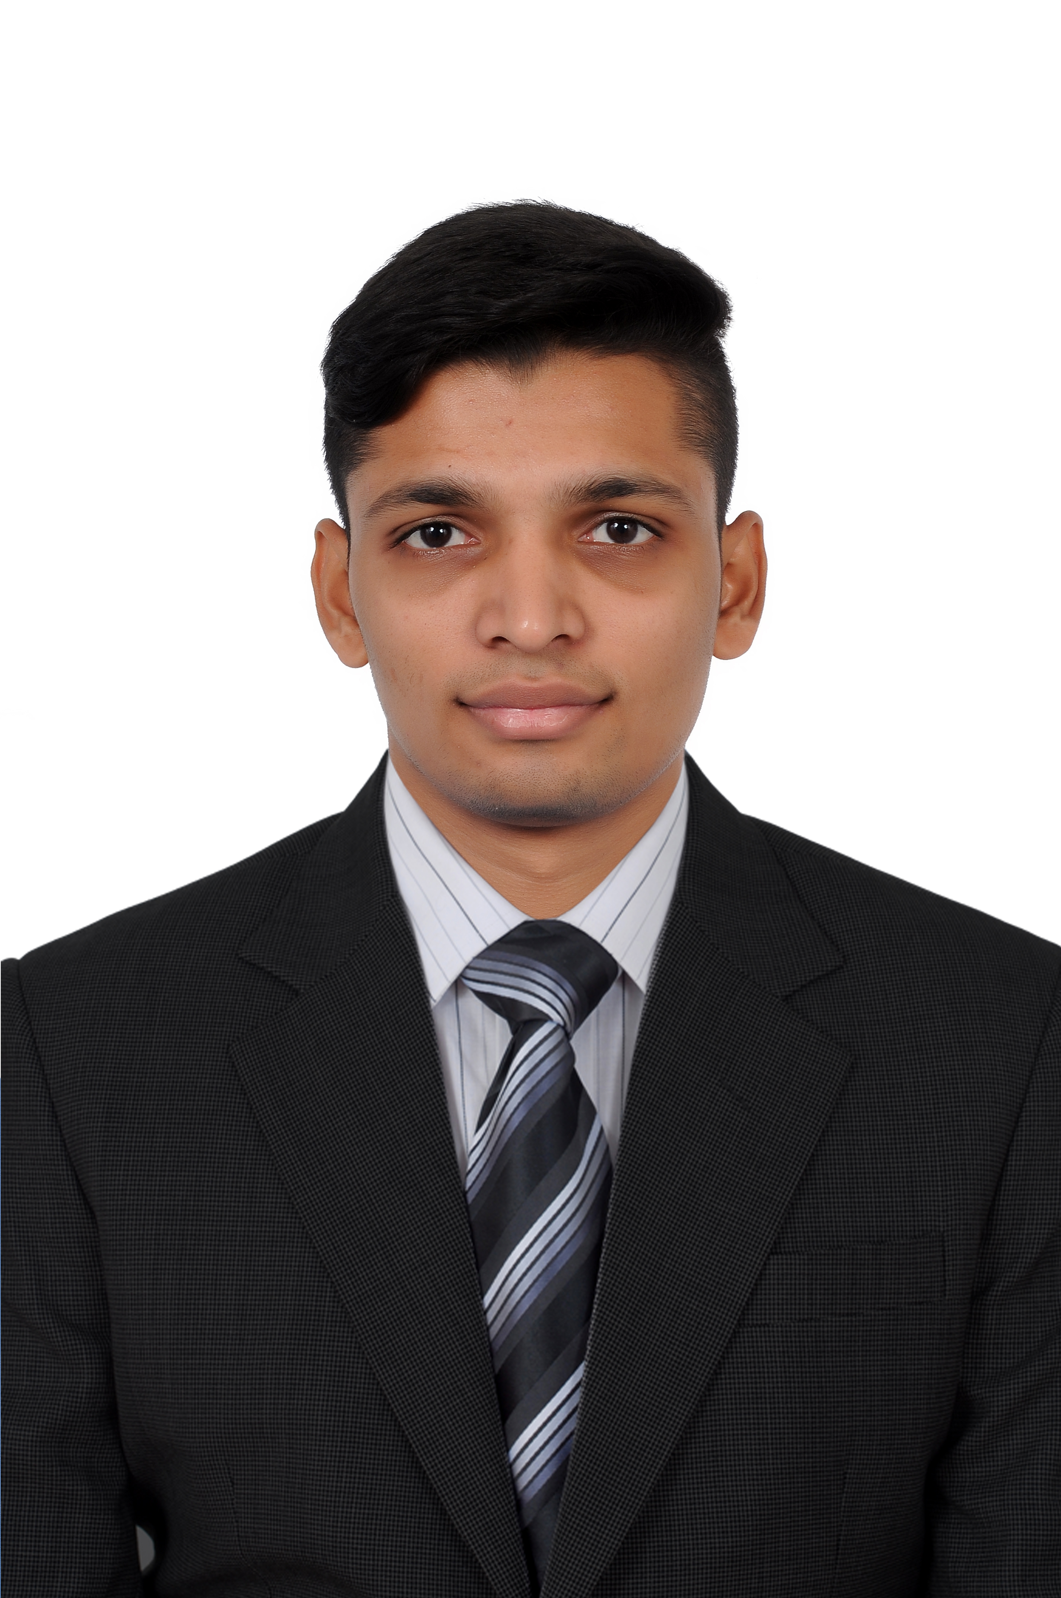

Adarsh
Email: adarsh.374193@2freemail.com

Objective To work, learn, and enhance my technical skills and grow in the esteemed establishment of your company. And also to contribute towards society through technological growth, while improving my knowledge and growth.

Education

Qualification Details | Year | Percentage
B.E. in Mechanical Engineering(V.T.U)  M.I.T.E, Karnataka, India | 2016 | 60%
Grade 12, Biology(P.U.E)  Alvas P.U. college, Karnataka, India. | 2012 | 88%

Project:
Intelligent Irrigation System by using Gravitational and Potential Energy of Swing

Achievements:
- Won first place at State level Quiz competition
- Second place at District level Hockey
- Participated in State level Hockey

Certified Courses
- Attended training conducted byBosch Rexroth Centre of Competence in Automation Technology on Hydraulics and Pneumatic Drive and Controls of Machineriesfrom February 2014 to April 2014.

- CADD Centre Training Services Certificate
Certified in Professional in Product Design and Analysis (September 2017)

Work Experience
Company Name: Alpha Meditech(recruited from Campus)
Job profile: Service Engineer( August 2016 to January 2017)

Overseas installation of equipment according to manufacturer’s specifications
Operate system to demonstrate equipment and to analyze malfunctions

Technical Skills
- Solid Edge.
- Femap(Nastran).
- AutoCadd
- ANSYS
- Nastran
- Catia

Co-Curricular Activities

- Attended various technical talks as part of curriculum for B.E.
- Participated in several technical and cultural events at inter-college festivals.

Traits and Attributes

- Self-confident, Hardworking, Honest and Responsible.
    - Quick learner and Team player.
    - Good analytic and problem solving skills.

Personal Details

Date of birth: 4thApril, 1994.

Nationality: Indian

Available Identity: Passport

Languages: English, Kannada, Hindi and Tulu.

Hobbies: Listening to music, playing Cricket, and watching Football

Declaration

I hereby declare that all the information mentioned above is correct, complete and truly stated to the best of my knowledge and belief.

Yours sincerely,
Adarsh

