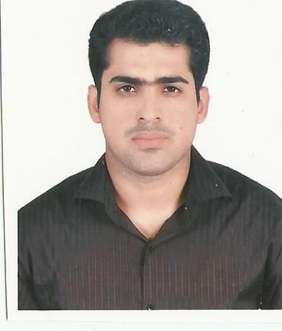
URRICULUM Imran
ITAE Abu Dhabi ,UAE
Email: Imran.374219@2freemail.com

Position: PR Assistant cum Typist

CAREER OBJECTIVE

Seeking as a PR Assistant cum Typist professional experience and education will allow me to make an immediate contribution as an integral part of a progressive company.

Qualification Background

I.COM
S.S.C Metric. Science

Academic Background

MS Office 2010 & 2013 (06 Month Certificate).
English Language NUML (03 Month certificate).

Key Strength

Administration,
Time Keeping,
Skillful, team player, Confident and multi-talented.
Quick Learner,
Typing speed of 50 wpm.
Fully physically fit with no addiction.
Fully computer literate with MS office computer software.
Able to work in a team environments.
Honest, hard working and methodical.
Good personality.
Communication.
Flexibility and Adaptability.
Creating a positive work environment.
Self Motivative.
Ability to work under pressure.

Job Profile

Dulsco HR Solution, HR Provider From Jan 2014 to Till date.
Associate Time Keeper Cum Admin Assistant.
MPS Operation Department, Abu Dhabi

- Preparing and following the new joining and rejoining formalities.
- Preparing the manpower report absent report continues absent report and submitting to the head administration.
- Arranging salary certificate NOC request salary transfer letter warning letter and salary increment letter.
- Computes total time worked by employees, using computer, post time worked to master timesheets and additionally routes timesheet to the payroll department.
- Locate workers on job at various times to verify attendance of worker listed on the daily spotter sheet be designated spotter any industry.
- May calculate time worked units produced by piecework or bonus work employees, using calculator or computer, and also designated time checker or work checker.
- Complying with employees’ time production records, using calculator or computer.
- Review timesheets, work charts, plus time cards for completeness.
- Preparing all worker releases resignations and termination.
- Arranging worker for visa medical, finger prints and passport renewal.
- Every month preparing staff & labor time sheet and monthly reports.
- Arranging for all staff air ticket and air ticket reimbursement procedure.
- Dealing with all staff workers.
- Emergency leave formalities.
- Staff visa renews or non-renew procedure.
- Working closely with PMV to arrange transportation for workers and staff members whenever required.
- Preparing Invoices.
- Coordinating with the training division to make necessary arrangements for worker trainings.
- Coordinating with hospitals and insurance companying case of medical emergency.
- Protects organization's value by keeping information confidential.
- Maintaining proper filing.
- Sending and Distribution of Incoming faxes and emails.
- Making document of emirates id, medical, Immigration etc.

Job Profile

Typist Cum PRO:-

Ayesha Husain Document Clearing. July 2007 to Dec 2013.

- Preparing document and submission all types of visa for Schengen, United Kingdom, United States, Canada, Australia and other major countries embassy in UAE.
- Code and process applications into required electronic format.
- Review and check applications and supporting documents.
- Typing for Emirates ID Card
- Dubai Immigration online (E-form) visa application processing
- All kinds of Consulates & Embassies documentation
- Creating Professional letters for Embassies and Consulates
- Hotel reservation
- Scan documents into the database.
- Audit on-line applications for accuracy and completeness.
- Load information into prescribed databases.
- Maintain complete activity logs and prepare reports.
- Respond to requests for information and statistics.
- Retrieve and present required information in various formats.
- Manage application changes.
- Communicate with applicants telephonically and in person.

Professional Experience

Total four (10) experience in the field of timekeeper cum Admin Assistant, Typist Cum PRO.

4 Years experience of a Time Keeper cum Admin Assistant Jan 2014 to till date.

Dulsco HR Solution Provider, LLC, Abu Dhabi.
- 6 Years experience as a Typist Cum PRO from July 2007 to Dec 2013.
Ayesha Husain Document Clearing in Dubai.

The Management Expertise

- Self-motivated & have the drive to overachieve on goals and targets set out.
- Confident & have effective selling skills.
- Having good listening skills.
- Excellent team player.
- Reliable and self-motivated

Interest____________________________________________________________________________
Study, Gathering Knowledge, Sports, & watching documentaries.

Languages ________________________________________________________________________
Excellent skills in speaking, writing and reading English, Arabic, Urdu.

Personal Information

Name: Imran
Date of birth: 05 October 1987
Place of birth: Dubai, UAE
Marital Status: Single
Nationality: Pakistani
Passport number: AW0765422 (Valid till 27th FEB 2017)
UAE Visa status: Cancelled Employment visa
Driving License: Yes UAE (Valid till 25th Mar 2025)

Imran

