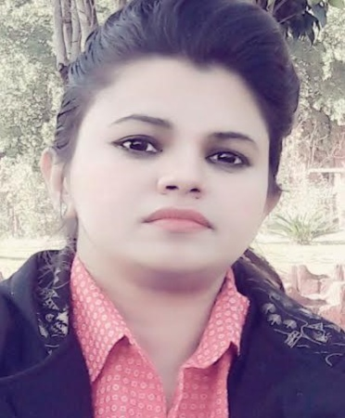
Amna

amna.374242@2freemail.com

OBJECTIVE
Seeking a convenient position in a School, an institute, a training center, or any place where my qualifications, experience, accomplishments, skills and proficiency will allow me the opportunity for growth professionally and technically.
EDUCATION

- M.phil in Biochemistry
PMAS Arid Agriculture University, Lahore, Pakistan.
- Bachelor of Honrs in Biochemistry
The University Of Lahore, Lahore, Pakistan.

- Intermediate (Pre-Medical)
From Board of Intermediate and Secondary Education Lahore, Pakistan

- Secondary School Certificate
From Board OF Intermediate and Secondary Education Lahore, Pakistan

Experience & Internship
- Noor College of Business and Sciences (August 20, 2015 – August 14 , 2017)
Worked as a Biology and Chemistry teacher for (grade 9-12)
IGCSE, Edexcel and F.sc

- Nova College for women Cantt Lahore (August 25- Nov 10, 2016)
Visiting teacher for Biology and Chemistry (grade 11-12).
- Society Public School, Mugalpura Lahore (March 26, 2013 – April 4 , 2014)
Worked as a Biology and Chemistry Teacher for (grade 9-10)
- Kinsley School system, Aziz puli, Lahore, Pakistan. (July 10,- Sept 29, 2011)

Worked as Biology and chemistry teacher for (grade 8-10)

- Sigma Science Academy, Lahore, Pakistan. (Jan 10, 2011- Dec 20, 2013)
Worked as Biology and Chemistry teacher for (grade 9-10)

Seminars & Certifications
- Workshop on teaching skills 2015.
At Noor college of Business and science
- English language and teaching skills 2015.

KEY SKILLS & EFFICENCIES
- Experienced science teacher.

- Ability to deal with all kinds and levels of science subject Classes & Class Control.

- Proficient in biology and chemistry experiments with excellent handling skills.

- Ability to learn the most up-to-date teaching strategies and implementing them accurately. (I’m Always upgrading my skills and trying to keep updated)
- Excellent Knowledge in MS Office Packages Excel and Word and Power Point.
- Self-motivated, Team player, Leadership, Creative, Dedicated, can work under challenging conditions & meet deadlines, Excellent communicator, Ethical, Confidentiality, Integrity, Methodical, Aptitude for figures, Computer literate and Quick learner.
- Tireless, target - Centric and result oriented.

- Adapting expertise with changing environment.
- Ability to establish teamwork.
- A strong willingness to learn new skills and abilities and observe perception.
- Initiative for taking new responsibilities and high interpersonal skills.

- Like to interact new people to know them, understand and help them when in problem.

- Good Communication, analytical and interpersonal skills.

PERSONAL Information
Nationality : Pakistani
Date of Birth: 04/06/1990
Passport Number: DA1206892
Religion: Islam
Visa Status: Visit Visa

*References are Available upon Request

