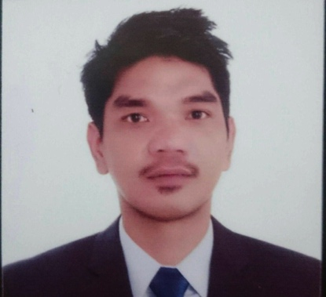
Ryan

E-Mail: ryan.374250@2freemail.com

Skills

A reliable, trustworthy and conscientious person who is able to multi-task, handle pressure, work as part of a team and most importantly inspire customers to make a purchase.

Personal Profile
Date of Birth | : | December 15, 1983
Place of Birth | : | Manila
Sex | : | Male
Height | : | 5’10
Civil Status | : | Single
Citizenship | : | Filipino
Language Spoke & Written | : | English and Tagalog
Passport Number | : | P3884424A
Visa Status | : | Visit Visa

Experience
- Pre-Delivery Inspection (Warehouse)
Company: Brills Marketing Corporation 2015-2017
Department: Maintenance
Responsibilities:
- Conduct inspection of vehicle upon arrival at warehouse.
- Check if the goods are intended to our company.
- Check if the quantity of actual goods are tallied versus the delivery receipt.
- Inspect the items if it is in good condition before unloading.
- Load the products onto trucks according to company’s SOP.

- Maintenance Electrician
Company: Power Readji Corporation 2013-2015
Department: Maintenance
Responsibilities:
- Perform replacement on diagnosed faulty electrical elements of machine including motors, relays, and switches, utilizing hand tools.
- Carry out diagnosis and correct or replace malfunctioning electronic units like the printed circuit boards.
- Carry out disgnosis and ensure replacement of pneumatic, mechanical, hydraulic components of equipment and machines which are faulty.
- Render assistance and manage contractors’ roles for electrical duties.
- Render assistance in administration and regulation of duties of junior technicians.
- Organize safe maintenance principles for regulating and scheduling breakdowns.

- Service Crew/ Cook
Company: Chowking (Restaurant Company) 2011-2013
Department: Kitchen
Responsibilities:
- Set up and stocking station with all necessary supplies.
- Prepare the food service.
- Cook menu items in cooperation with the rest of the kitchen staff.
- Clean up station and stock inventory appropriately.
- Ensure that food comes out simultaneously in high quality and in timely fashion.
- Comply with nutrition an sanitation regulations and safety standards.
- Maintain a positive and professional approach with co-workers and customers.
Education Vocational Education - Electrician | 2011
Electron Training Center
Secondary Education | 1997 - 2001
General Emilio Aguinaldo Integrated School
Primary Education | 1991 – 1997
General Emilio Aguinaldo Integrated School

