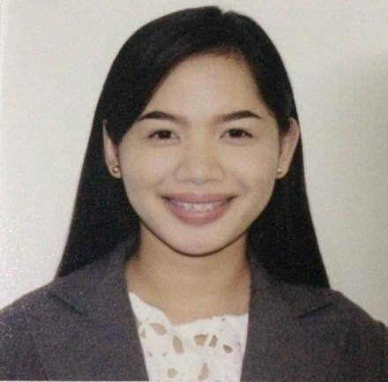
CLAIRE
Address: Dubai
E-mail address: Claire.374251@2freemail.com
Visa Status: Visit Visa

OBJECTIVE

To contribute the company’s success by applying my acquired skills, knowledge and experience as hotelier and as a sales that build a good relations and to improve my ability to work well with people.
EXPERIENCE, TRAININGS AND SEMINARS

EXPERINCE
April 8, 2016 - January 8, 2017
Employee of Henady Inn Main/Annex under Front Office/ Housekeeping Department in 9 months.
Duties and Responsibilities
- Maintain the good relation with the guest/s.
- Always smile when communicate and entertaining the guest/s.
- Maintain the cleanliness and orderliness of the establishment.
- Always familiarized about the kinds and prices of the rooms.
- Being alert in check-in/check-out guest/s.
- Can handle guest complains.
- Greeting all arriving guest/s.
- Do an inventory.
- Checking all rooms and reservations.
- Answering telephone calls and emails.
February 2, 2017 - August 2, 2017
Employee of Mart One under sales assistant in 6 months.
Duties and Responsibilities
- Being familiarized about the location of your products.
- Always smile when greeting them and be presentable.
- Do an attractive display and inventory.
- Build productive trust relationships with customers.
- Know your responsibilities as an employee.
- Answering queries and assisting customers.
- Team up with co-workers to ensure proper customer service.
- Remain knowledgeable on products offered and discuss available options.
TRAININGS AND SEMINARS
November 16, 2015 – February 10, 2016
Successfully completed 600 hours of
On the Job Training in housekeeping, food and beverages and front office department at Astoria Plaza.
Sept 2, 2014
Front Office Procedures and Opera Management System Training
Held at City Garden Suites, Manila, Philippines
March 2, 2014
Housekeeping Seminar with Hotel Familiarization Tour
Held at Hotel Luna, V. Delos Reyes Corner Gen. Luna St. Vigan City, Ilocos Sur Philippines
HIGHEST EDUCATIONAL ATTAINMENT

COLLEGE
Bachelor of Science in Hotel and Restaurant Administration
University of Northern Philippines
2012-2016
SKILLS AND ATTRIBUTES

● Perform Good Services ● Workmanship
● Events Management ● Courtesy
● Provide Food and Beverage Services ● Industry
● Front Office Management ● Fear of God
● Trustworthy
PERSONAL BACKGROUND

Address : Dubai
Date of Birth : April 4, 1996
Height : 5’2”
Civil Status : Single
Citizenship : Filipino
Passport : P0501848A
Valid Until : October 3, 2021
Religion : Roman Catholic
Language Spoken : English, Tagalog

CLAIRE
APPLICANT

