RESUME

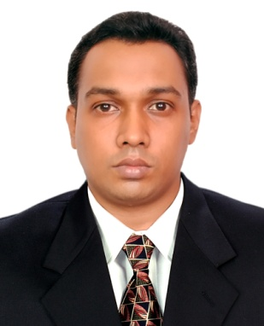
ANEESH
Dubai
Mail id: aneesh.374295@2freemail.com

______ ________
CAREER OBJECTIVE:
To work in an organization where I can acquire new knowledge and skills for securing challenging positions ; by utilizing my strong technical, analytical and team building skills, also for the achievement of organization’s as well as individual goals.
PROFESSIONAL EXPERIENCE

Well care Surgicals, Thrissur ,Kerala, India (21 March 2014 - 31 August 2017 )

Job Profile

Well-Care surgical is a medical service organization based in thrissur which holds a legacy of 15 years in healthcare sector in South India. Well-Care surgical is a dealer in sales and a prime level service provider of SKANRAY

Duties and Responsibilities of Job
Maintenance and servicing of various equipments and apparatus like Monitors (Planet and Star series), Defibrillators (Skan-Revive), Electrocardiogram (cardiskan) , Ventilators (Skan-Respiro), Anesthesia machine (Athena SV400,SV200), Electro surgical unit (Maestro Seal plus, Maestro plus 100),Syringe and infusion pump (SP 105,205, IP 101)
EDUCATIONAL QUALIFICATION:

- Completed Biomedical Engineering in the year 2010 with 64%
- 12th board exam passed in the year 2003 with 65%
- 10th board exam passed in the year 2001 with 88%

COMPUTER SKILLS:
- Programming Languages : C Programming , C++
- Microsoft Word, Excel & Power Point : Very Good

ACHIEVEMENTS:

- Won prizes in school and college level quiz competition
- Got prizes in games and arts competitions conducted in our college
- Visited Super speciality hospitals, Hardware & Software companies
- College team member for cricket
PROFESSIONAL AFFILIATIONS
- Member – The Biomedical Engineering Society of India ( BMESI)
- Member – Indian Society of Technical Education (ISTE)
INTERNATIONAL/ NATIONAL CONFERENCE ATTENDED
- BIOVISION 2K6- International Conference on Food Biotechnology.
- MEDCON 2006- South India Level Symposium in cyber age
- MEDCON 2008-09-national conference on medical imaging and prosthetics
- MEDCON 2009-national conference on perceptions in biomedical engineering and healthcare informatics

SKILLS

- Good presentation skill.
- Very strong leadership and organizing skills.
- Demonstrated presentation skill and a good Team Player.
ACADEMIC PROJECTS:

- “ Finger plethysmography ” in 6th semester as part of the curriculum (mini project) :
Aim of project is to measure the blood resistance by using the plethysmography technique. This resistance measurement will help to detect various disorders. We use lab view software for our project. We completed this project successfully and tested
- “ Surgical system with haptic feedback ” in 7th & 8th semesters as a part of the curriculum (main project) :
Objective of our project is to assist the surgeon in robotic surgery .Our aim is to feedback the force applied by the surgeon during surgery by using touch sensation. So that by sensing the haptic feed back surgeon can do modifications and he will be able to do the surgery more efficiently. Our project has been completed successfully.

ACADEMIC SEMINAR:

- Hospital Waste Management
- Measurement of VEP by using graded contrast stimulus(curriculum seminar)

PERSONAL DETAILS:

Date of Birth : 31/05/1986
Gender : Male
Languages known : English, Malayalam& Hindi

DECLARATION:

I hereby declare that the information furnished above is true to the best of my knowledge.

DATE ANEESH

