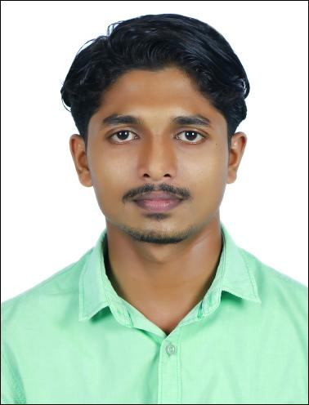

CALLWYN
Al Rigga, Dubai, UAE
Email: callwyn.374311@2freemail.com

Profile
4 years of experience in Design Engineering, Project Executions, Operation Management, Quality Management. Strong abilities in creating/interpreting engineering drawings with proficiency in designing & developing new products in conformance to pre-defined technical specifications.

EMPLOYMENT
- ROYAL ENFIELD- St. Mary’s Motors Pvt Ltd. 05th Aug 2013 to 10th Sep 2016

Service Advisor & FQI/PDI.

- Availing prompt and excellent service to the customers accordingly.
- Authenticating the customer issues through proper analysis of the vehicle.
- Maintains scheduled work allotment by monitoring vehicle condition; coordinating activities and resolving problems.
- Controlled labor utilization; conduct meetings with customers and Service Manager, for the upbringing of customer satisfaction.
- Prepare Service Reports by collecting, analyzing, and summarizing information, Customer reviews and trends; recommending actions.
- Cordial participation and presentation of Weekly Analysis Report of the service center in the weekly RSA- Meetings conducted by the Plant Authorities from Royal Enfield Chennai.
- Contributes to team effort by accomplishing related results needed for the company.

- CROMPTON GREAVES- Unique Diesel Pvt Ltd. 15th Sep 2016 to 30th Sep 2017

Service Engineer

- Avail assistance in Pre-commission, Commission, Installation, AMC and total Service overhauling.
- Cordial participation in quoting for services and AMC related documents preparations.
- Authenticating engine parts to be serviced/replaced in time to time service intervals and providing quotations.
- Supervising in conducting commissioning to overhauling under trained technicians.

Academic Profile

- B-Tech
BE Automobile Engineering (Anna University, Chennai) 2013
Projects
- Main Project: “Fabrication of Automatic Pneumatic Differential Lock Unit”
Duration : September 2012 onwards

Description : Using the differential hub of the car.

- Mini Project: “Automatic Hydraulic Jack”
Duration : December 2011 – May 2012.
Description :” Electronically-operated Hydraulic Jack”
Seminar Presentations
- Actively participated in AUTOBOTICS (Workshop on intelligent Autonomous Robotics) held at TAMILNADU COLLEGE OF ENGINEERING, COIMBATORE.

- Participated in ONE DAY WORKSHOP on RECENT TRENDZ IN ENGINES AND AFTER TREATMENT SYSTEMS FOR AUTOMOBOLE APPLICATIONS organized by SAEBIT club on 15th September 2012.

- Presented a paper in the inter college contest organized by SAEINDIA-SKCET collegiate India club about “ZEROSHIFT”.

Industrial Exposure
- A week of Industrial training at ARAI, Pune, Maharashtra.
- One week training at the Royal Enfield Production Plant- Chennai.

Technical Expertise
- Electives:- Automotive instrumentation, Two and three wheeler, Automotive embedded systems, Off road vehicles
- Software Known: - Pro-Engineer, Solid Edge, ANSYS.

