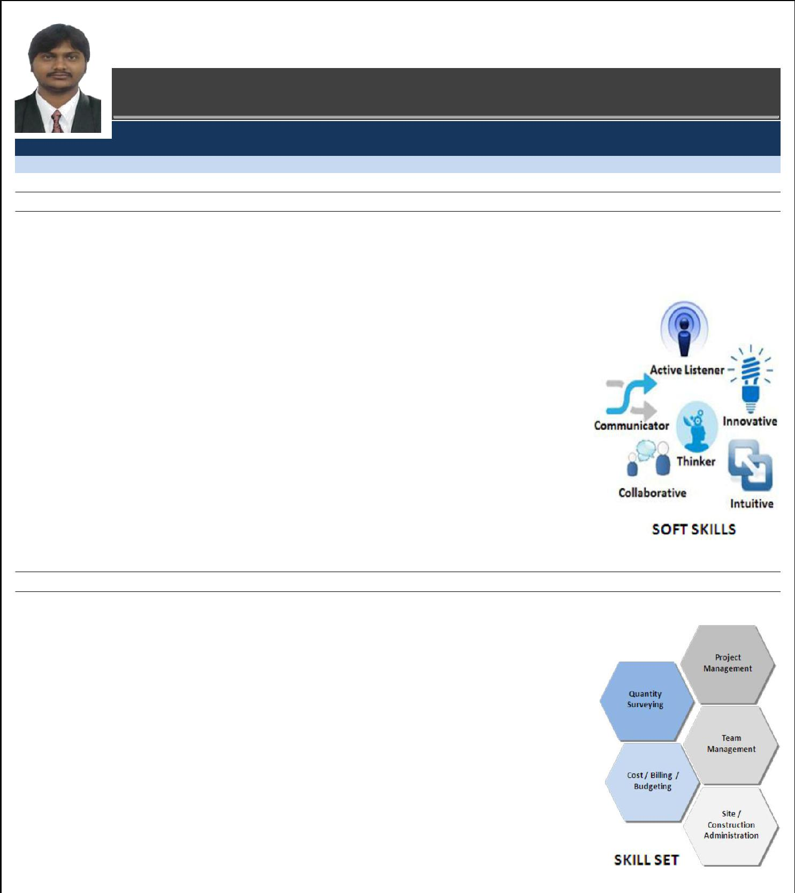
Avinash

E-Mail: avinash.374316@2freemail.com

M I D D L E L E V E L P R O F E S S I O N A L

Q U A N T I T Y S U R V E Y I N G | P R O J E C T M A N A G E M E N T

-Scaling new heights of success with hard work & dedication and leaving a mark of excellence on each step; aiming for challenging assignments with a leading organization of repute, preferably in Construction industry
Location Preference: INDIA,UAE,OMAN,KUWAIT,QATAR

P R O F I L E S U M M A R Y

B.Tech. (Civil Engineering) with 9.4 years of commendable experience in:

~Project Management

~Procurement

~Contract Management

~Quantity Surveying

~Cost / Billing / Budgeting

~Site / Construction Administration

Capable of managing overall project life-cycle of international repute right from development to delivery encompassing planning, monitoring, overall inter-discipline co-ordination and

resource planning
Proficient in developing request for purchase quotes and reviewing procurement volumes by
product class / customization / type, thereby identifying areas for win-win negotiation
strategy / frame contracts and finalising the same
Skilled in managing site technical administration involving estimation, site inspections,

techno-commercial negotiations and settlement of bills
Competent in managing contract (pre & post) activities involving techno-commercial studies (technical & commercial aspects), failure mode, cost benefit analysis and tendering (floating,

analysis, negotiation, conclusion & close-out of contract)
Proven abilities in liaising with clients, vendors, contractors, sub-contractors, consultants
and statutory bodies for optimal resource utilisation
Efficient organizer, motivator, team player and a decisive leader with the ability to motivate teams to excel and win

A R E A S O F E X P E R T I S E

Contract Management:

Assuring the effective management & implementation of Contractual deliverables Actively involved in variation order submission & approval

Procurement:
Conducting analysis and developing new budgeted cost for cross-checking the project viability

Formulating budgets, conducting variance analysis to determine difference between projected & actual results and implementing corrective actions accordingly
Project Management:

Tracking project activities with the key emphasis on quality, drawings, specifications,

standards & codes; reviewing schedule & handling budget for cash flow requirements
Preparing the project evaluation framework to assess the strengths & identify the areas of improvement; ensuring that all activities are operated as per policies of organization

Site Management:

Looking after construction operations involving handling procurement, inviting quotations and codes analysis of rates and
stacking / storing raw materials to ensure uninterrupted supply as per pre-set standards

Inspecting field sites to observe and evaluating site conditions for availability of resources to collect data & measurements

Quantity Surveying:
Preparing cost proposals, contracts & documentation and responding to tenders & requests in a timely manner

Actively involved in conditions of contract and standard methods of measurements; drafting tender / contract documents and cost estimates including billing, variation / deviation proposals, claims, etc.

 |  | O R G A N I S A T I O N A L E X P E R I E N C E
Since Jun’08 | Larsen & Toubro Construction, Hyderabad as Site Engineer / Planning and Billing Engineer at Dahej,
 | Halol/Finishing Engineer at Bangalore/Convrgnt Value Engineering, Quantity Surveyor at Dubai
Growth Path / Assignments Handled:
Jun’08 – Oct’09 |  | Site Execution Engineer at Commercial Building for Phoenix
Site Oct’09 – Mar’12 |  | Billing Engineer at Rallis Agrochemical Plant, Dahej in
Planning
 |  | Department
Jan’11 – May’15 |  | Planning & Billing Engineer at Torrent Pharmaceuticals Site,
 |  | Dahej in Planning Department
May’15 – June’15 |  | Planning & Billing Engineer at Hero Motocorp Ltd, Halol
 |  | in Planning Department
June’15 – November’15 |  | Finishing Engineer at Prestige ferns Residency, Bangalore.
January’16-Till Date |  | Quantity Surveyor-Post Contract in Covrgnt Value Engineering LLC., Dubai..

Role: (Across the tenure)
Preparing:

o Monthly client bills & the certification of the same

  - Assessing interim Payment application for Building and Infrastructure work.

  - Preparation of Bill of Quantities in accordance with drawings and specifications for various Tenders.

  - Evaluation of the variations in Civil & Infra structure work.

  - Maintaining records of variation accounts.

  - Preparation of Monthly financial reports & cash flow.

  - Comparison statement for work progress and negotiation with Engineer for evaluation of Contractor’s payment application.

  - Tracking of Man power utilization against budget productivity and highlighting the variation.

  - Reconciliation for client supplied materials, bulk materials & specialized items

  - Subcontractor Bills, Work Orders LOI,s etc. in the System

  - Monthly client versus Subcontractor Reconciliation

  - MIS reports to be presented to the management

  - Job Cost Report (JCR) for keeping track of cost of project on monthly basis

  - Accepted Cost Estimate (ACE) before starting of the project to ensure profits.

  - Preparation of Contract Agreements for Sub-Contractors.

Interacting with the Site Team for ensuring field activities are carried out as per the drawings Conducting rate analysis
Performing revision of BOQ (Calculation of Quantities for all Items)

Calculating Estimate to Complete (ETC) on monthly basis for tracking the cost & margin of project

Organizing meetings with the clients and consultants for understanding the requirements and offering an appropriate solution for the same
Coordinating with the vendors for placing the orders

Monitoring the project status by preparing pictorial views

Executing Finishing works, joinery & landscaping works at the site.

Ensure that any contract warranty requirements are incorporated into relevant subcontract documents. Ensure adherence to all stated policies and procedures throughout the project stages.
Ensure effective and efficient utilization of resources in the Unit. Submit reports and other deliverables to the Project Manager. Perform any other duty as requested by the Project Manager.

Highlights:

Holds the merit of being rated as ‘TOP Performer’ in L&T consistently for 5 years (From 2010 to 2015)

Played a key role in adding new revenue streams by timely recognition and discussion of issues with clients & Management Received appreciation from clients Rallis India Limited, Torrent Pharmaceuticals Limited for executing Rallis Agrochemical
Plant & Torrent Pharmaceuticals Dahej.

ACADEMIC DETAILS

2015 B.Tech. (Civil Engineering) from J.R.N Rajasthan Vidyapeeth University with “B Garde”.

2008 Diploma (Civil Engineering) from Government Polytechnic Visakhapatnam, State Board of Technical Education & Training, Andhra Pradesh with 83%.

2005 Class X from Little Flowers Public School, Pendurthy, Board of Secondary Education, Andhra Pradesh with 86%

IT SKILLS

AutoCAD

MS Project

MS Word, Excel, PowerPoint and Internet Applications

E X T R A C U R R I C U L A R A C T I V I T I E S

Participated and won Regional Cricket Tournament twice

Cleared IT Awareness Exam with A Grade conducted by Indian Computer Institute Association

Bagged 1st Prize in Essay Writing Competition at Interschool Level

PERSONAL DETAILS
Date of Birth: 24th May 1990

Nationality: Indian

Marital Status: Single

Languages Known: English, Hindi & Telugu

No. of Dependents: 05

Passport Details: M3549512 (Issued at Surat. Valid up to 11’11’2024)

