RESUME

SUMITH 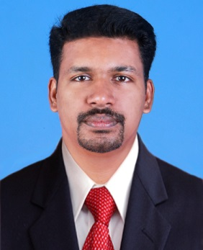
Email: sumith.374319@2freemail.com
Career Objective
To work in highly professional environment that requires innovation and dedication leading to achievement of organizational goals and objectives.

Work Experience
2.2 years of experience as Assistant Sales Manager at Dalman Group
3 years of experience as Administrative Officer at St. Celestine School of English

Personal Competencies
Hardworking, Team Handling Skills, Computer skills, Communication Skills, Quick learner, Responsible and trust worthy
Executive Summary
- MBA in Finance and Marketing with 5 years of experience in Sales and Administration.
- Handled Dealers and Retailers Successfully.
- Improve the goodwill of the organization successfully.

Achievements
Got Second place in the event “BEST MANAGEMENT TEAM” in the South Indian Management Meet at John Mathai Centere, Thrissur.
Worked as the Administration coordinator in Eminence 2011 (South Indian Management Meet of our College)

Projects
Done a 45 days project on the Subject “FUNDAMENTAL ANALYSIS OF FOUR COMPANIES LISTED IN THE NIFTY MIDCAP 50 STOCKS” in Balance Equity Broking (India) Pvt. Ltd.
Done a one month project on the subject “A STUDY ABOUT THE ROLE OF ADVERTISMENT IN BRAND BUILDING” in Bhīma Jewellery Thrissur
Educational Qualifications

Course / Degree | Institution & University | Aggregate Percentage/Grade | Year of Completion
MBA | Elijah Institute of Management Studies, Thrissur, Calicut university | C | 2012
B.com | Sibga Arts and Science college, Irikkur, Kannur University | 56% | 2009
Plus two | Government Higher Secondary School, Irikkur, Kannur | 52% | 2005
SSLC | KPC Higher Secondary School, Pattannur, Kannur | 66% | 2003

PERSONAL DETAILS
Gender : Male
Date of Birth : 10-10-1987
Religion : Christian
Marital Status : Married
Nativity : Indian
Languages known : Malayalam, English
DECLARATION
I hereby declare that the above written particulars are true to the best of my knowledge and belief.
Sumith

