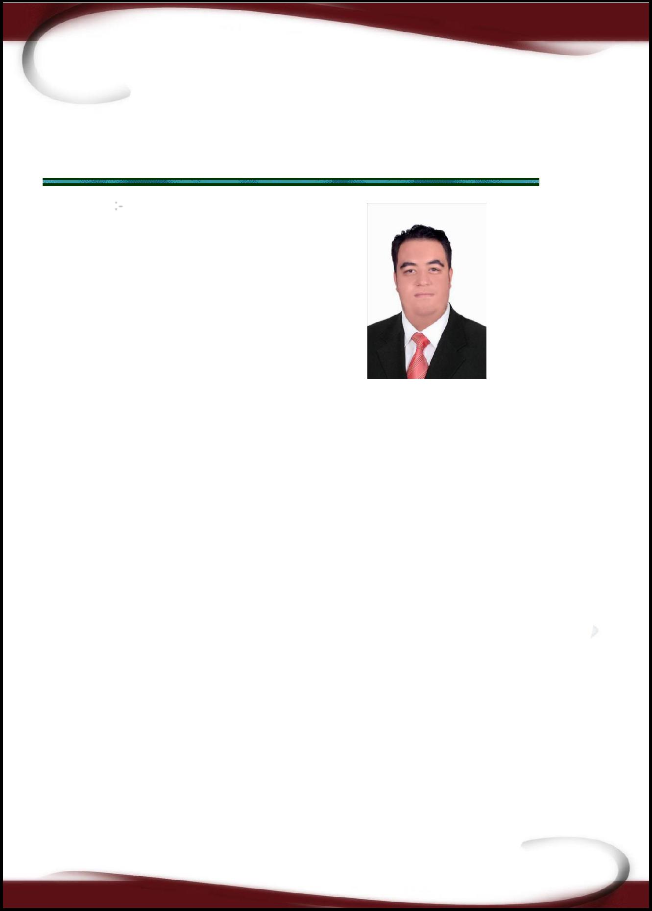

Razik

E -Mail: razik.374321@2freemail.com

PERSONAL DATA:

Nationality: Egyptian

Date of birth: 07/05/1991

Marital status: Married

Adress: UAE.AJMAN

Education:

Bachelor of Civil Engineering

Graduate from H.I.O.E El Shrouck Academy

Graduation Year: 2012.

Degree of Bachelor Graduation: Good

Graduation Project : Projects Management

Grade : V.Good

Experience:
.A technical office engineer at EL TABARAK company for contracting and engineering s

Job description: make time scheduling , prepare subcontractors extracts, owner's extract,

Project title : The establishment of 44 residential buildings with 1056 apartments with Cost 143 milion L.E from 5/2014 -9/2017
.Site engineer at EMAK for engineering from 8/2012 – 5/2014

Project description: The establishment of 2 hotel buildings , 3 swimming pools ,restaurant, party center with Cost 186 milion L.E

COURSES:

AUTODESK STRUCAL REVIT

PRIMA VERA

AUTO CAD

MICROSOFT OFFICE

Language Skills:

V .good writing, reading , speaking ENGLISH

PROFILES :

- Ability to build constructive social relations.

- Ability to be an effective member of a team work .

Thank you for saving time in reading my CV.

Eng: Razik

