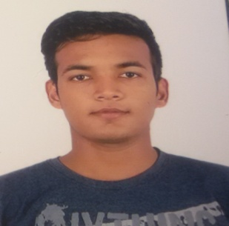
FIROZ
Dubai,(UAE)
Mail: firoz.374325@2freemail.com

CAREER OBJECTIVE:
To have a growth oriented and challenging career, where I can contribute my knowledge and skills to the organization and enhance my experience through continuous learning and teamwork.
ACADEMIC QUALIFICATIONS:
- Matriculation
- Passed in 2011 from CBSE board with 7.2 CGPA

- Intermediate
- Passed in 2013 from CBSE board with 52 percentile.

PROFESSIONAL QUALIFICATION:
- B.Tech (Mechanical Engineering) with 78 percentile from Al-falah School Of Engineering & Technology, Faridabad ,Haryana (India).
Academic Project:
- Project title: "Window AC 1.5 Ton With Rotary Compressor"
- Duration: January 2017 - March 2017
LINGUISTIC PROFICIENCY:
- English (Written & Spoken).
- Hindi (Written & Spoken).

TECHNICAL PROFICIENCY:

- Operating System: Window.
- Software's: Microsoft office, Basic skill in Auto CAD

WORK EXPERIENCE:
- Fresher

AREA OF INTEREST:
- Oil & Gas (Production and field service)
- Constructions
- Quality Control

STRENGHTS:
  - Positive attitude & co-operative.
  - Ability to absorb the work pressure and deliver desired result.
  - A team player & extremely goal oriented.
- Problem solving ability.
- Quick learner, innovative and adopt easily to new situation.
HOBBIES:
- Interacting with people & help others.
- Playing cricket
- Traveling to new places

Personal Details:

Date of birth : 25/08/1996
Civil Status : Unmarried
Religion : Islam

I hereby certify that the above information to the best of my knowledge and belief are true and correct.

FIROZ

