CURRICULUM VITAE

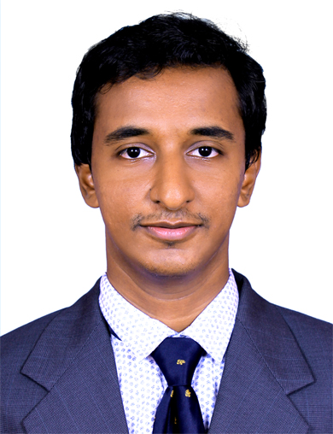
SHAWN

email: shawn.374342@2freemail.com

OBJECTIVE

To establish world class civil engineer with effective utilization of knowledge and experience gained. Seeking a challenging and rewarding carrier and on encouraging work environment, which help in materializing dream to contribute significant in the development of emerging technologies.
EMPLOYEMENT DETAILS
- Sajith & Sajesh Associates
Role: Civil Engineer
Period: August 2016 to September 2017

Responsibilities:
- Working under the Project Manager for scheduling of the project, planning of resources with respect to timely resource availability.
- Executing all works as per standard approved drawings.
- Monitoring store function and ensuring all documents updated.
- Ensure that material ordered is not more than estimated quantity.
- Attending Site meeting and clients and consultants.
- Checking Quality of works.
- Allocation of jobs for the employees at different sites

EDUCATION PROFILE

- B.TECH, Civil Engineering , M.G University
- HIGHER SECONDARY (2009-2011), SCS HSS Thiruvalla
- S S L C , Sarvodaya Vidyalayam , Trivandrum (2009)

ADDITIONAL QUALIFICATION
- Autodesk Certified Professional
- Quality Control Engineering
- Quantity Surveying & Estimation
- NDT Certificate
Level II Certificate in Concrete Half cell Potential
Level II Certificate in Concrete Rebar Locator
Level II Certificate in Concrete Radiographic Testing
Level II Certificate in Concrete Ultrasonic pulse velocity Testing
Level II Certificate in Rebound Hammer
- Revit Architecture 2015

PERSONAL DETAILS

Date of Birth : 03-06-1993
Sex : Male
Marital Status : Single
Fathers Name : John Varghese
Languages Known : English, Malayalam and Hindi.
Nationality : Indian
Place of issue : Trivandrum
Date of expiry : 13/09/2022
Visa Statues : Visiting Visa

DECLARATION

I declare that the information and facts stated herein are true and correct to the best of

my knowledge and belief.

Truly,

