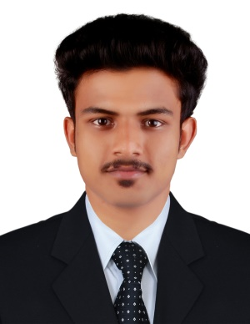
CURRICULUM VITAE

HISHAM
E-mail: hisham.374343@2freemail.com

Career objective
Seeking employment with a company where i can use my talents and skills to grow the company

WORK EXPERIENCE
Worked as a Draughtsman Civil in NECHIKATTIL CONSTRUCTION, Kerala – India
( From July 2016 to July 2017 )
RESPONSIBILITY
- AutoCAD Drawing
- Interior & Exterior Designing
- Site Supervise

ACADEMIC QUALIFICATION

NAME OF THE DEGREE | YEAR OF PASSING | INSTITUTION | UNIVERSITY/BOARD
Draughtsman Civil | 2016 | Edavanna ITI  Kunduthode | N.C.V.T
Plus Two | 2014 | JamiaNaddwia HSS  Edavanna | Board of Higher Secondary Examination
SSLC | 2012 | Islahiya HS  Panthalingal | Government of Kerala

TECHNICAL QUALIFICATION
- Adavanced Interior Designing in ALPHATECH ,Kerala-India
- Diploma in Civil Engeneering ,Kerala-India

SOFTWARE SKILLS
- AutoCAD
- 3ds Max With Vray Lighting
- Adobe Photoshop
- Microsoft Word
- Microsoft Excel

OTHER ACTIVITIES AND HOBBBIES
- Active member in Arts and Sports Club
- Playing Football, Listen to music

personal details
Date of birth : 08-07-1996
Gender : Male
Marital status : Single
Religion : Islam
Nationality : India
Languages known : English , Malayalam

PASSPORT DATA
Passport No : P3693891
Place of issue : Malappuram , Kerala-India
Date of issue : 07/11/2016
Date of expiry : 06/11/2026

DECLARATION
I hereby declare that all the above information is true to best of my knowledge.

HISHAM

