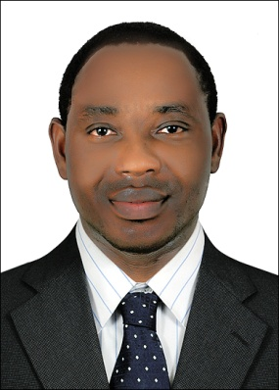
CURRICULLUM VITAE
Visa Status: (Employment)
Email: Takor.374367@2freemail.com
Objectives:
Seeking for a new and challenging position in a Company where I will significantly contribute to the environmental Norms and quality enhancement within industrial operation; through effective control, follow-up and implementation of Health, Safety,Environmentand social management plan, waste management plan, within national and international standard.
Competence and Skills:

Motivated, initiative and high level of energy, Strong personality, Staff supervision and ability to initiate/manage cross-functional teams, easy to deal with, Documentation and record keeping skills, high respect with everyone, Written and verbal communication skills, trustworthy, accuracy in preparing assigned task, flexible in terms of working capabilities, Proficient in MS Office Applications, Proactive in promoting Health & Safety in daily activities.

Al Farida Company – Abu Dhabi
HSE Assistant 2013-present

Cameroon Alert System (CAS) Construction Company-Cameroon.
HSE Assistant 2008-2012

Role responsibilities

Ensure a safe working environment without risk to health.
Ensure that all health and safety policies, procedures, rules and regulations are adhered to and are regularly reviewed, updated and communicated.
Established full programmed of documented health and safety inspections, audits and checks

- Monitor all the Job activity at the site to ensure safety compliance.
- Monthly Inspection program of Site equipment and Firefighting equipment to ensure safe operation.
- Installation of safety signs, traffic control signs and other safety promotion posters to remind workers to work safely and enhance safety awareness among them.
- Reviewing Lift Plan and Permit to work before any complex lift.
- Verifying to confirm that all lifting equipment operators are trained, competent and certified.
- Maintaining records of PTW’s to be available for auditing as required by company standards
- Assist Supervisor/Foreman for the Job Safety Environment Analysis and Risk assessment for all working & practices at site
- Prepare & Submit daily safety reports / Inspection Reports.
- Increase and apply the awareness on health and safety levels within the organization.
- Conducting Toolbox Talk weekly & as per Task required.
- To record and maintain a database of all inspections conducted to follow up and identify corrective actions.
- Managing all Commercial and Technical Document
- Distributing Documents and ensuring Accuracy of all Documents

Education:
Cameroon College of Arts and Science
- High school Diploma.
Series: Biology, Economics, Geography, Pure Math with statistics

Other Trainings:
Geigle Safety Group – Beaverton USA
Occupational Safety and Health Management
- OHSAS 18001/2007
OSHA Certificate
- Working towards NEBOSH Certificate Accreditation.

Home country driving license
Issue 20/10/2016
Expires 20/10/2026

Special Aptitudes:
- Confidential in all matters.
- Professional approach, coupled with strong interpersonal skills.
- Ability to work on own initiative.
- Ability to work in, and adapt to a rapidly changing environment.
- Ability to work co-operatively with others to complete task and implement process improvements.

Disposition:
- Flexible and co-operative at all times.
- Self-motivated

Language proficiency: English and French

Computer :( MSWords, excel, opera and ONQMS)

I hereby declare that all the information provided above is true and best of my knowledge

