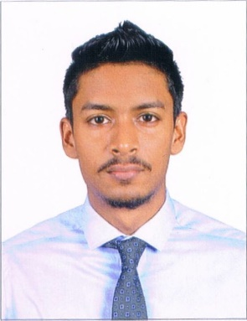

RYAN
RYAN.374369@2freemail.com

CAREER OBJECTIVE
My employment goals center on securing an appropriate position to prove myself of value in a reputable organization, which will provide growth opportunities with effective utilization of my skills and experiences and also the opportunity to learn more in a professional atmosphere.

EDUCATION
Bachelor of Business Administration (BBA): Travel & Tourism
St. Xavier’s College 2015

High School Diploma: Commerce/Vocational Studies
St. Xavier’s High School - Goa, India 2012

TRAINING/SKILLS
- MS Office Suite

WORK HISTORY
Alcon Hyundai – Goa, India
22nd February 2016 – 7th January 2017
Sales Executive:
- Generating enquiries from the field.
- Organizing and attending promotional events.
- Online marketing through social networking.
- Providing test drives to customers.
- Showing and explaining all vehicle features and functions.
- Determining the needs and desires of the customer to show them viable options.
- Drafting all necessary paperwork for the purchase of a new car.
- Assisting customers with the entire booking formalities upto delivery.

Honda Motors – Goa, India
14th August 2015 – 30th November 2015
Customer Service Representative (Part Time):
- Greeting customers upon entry and aiding them with their inquiries.
- Dealing with customer queries by phone, mail and face to face.
- Resolving customer grievances and providing satisfactory solutions accordingly.
- Ensuring customer satisfaction.
- Escalating calls to relevant departments when required.
- Promoting the supportive image of the company in every way possible.

Lemon Tree Amarante Beach Resort – Goa, India
22nd April 2013 - 5th June 2013
Front Office/ Human Resource:
- Greeting guests and handling check in and check out.
- Resolving guest issues and maintaining customer satisfaction.
- Maintaining and filing all customer reservation details in a proper manner.
- Ensuring cleanliness in the front office.
- Maintaining records and details of all employees.
- Maintaining daily attendance record for all employees.

STRENGTH
- An effective communicator
- Capable of working under pressure
- Efficient / target achiever
- Self-motivated
- Honest / Trust worthy
- Easy learner
- Enthusiastic to take up responsibilities / Team Player

PERSONAL DETAILS

Gender : Male
Date & Place of Birth : 15th March 1993, Goa, India
Religion : Roman Catholic
Nationality : Indian
Languages Known : English, Hindi and Konkani
Driver’s License : Valid Indian Driving License
Visa : Visit
Reference : Available on Request

DECLARATION
I hereby declare that the above particulars are true and correct to the best of my knowledge and belief and in the event of any information being found false or incorrect, my candidature will be liable to be canceled.

THANK YOU

