CURRICULAM VITAE
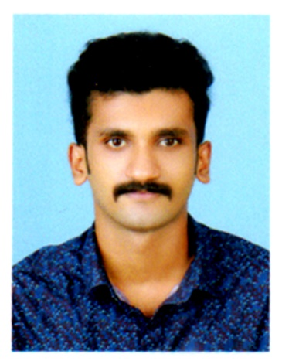

AKHIL
Email: AKHIL.374385@2freemail.com

OBJECTIVES:

Seeking an opportunity to contribute in a challenging position in the field of industry that could make best use of my knowledge, skills and values acquired through extensive education and experience.
PERSONAL DETAILS:

- Good interpersonal and communication skills
- Highly proficient in dealing frontline tasks and responsibilities
- Programming language C, C++, VB, PHP
- Confidence to take up responsibilities and challenge
- Main Project online footwear shopping
PERSONAL DETAILS:

MBA | Bharathiar University | 2017 | 1st year completed  On going
Diploma/Logistics  (Shipping & Retail Management) | Centre for Continuing Education Kerala | 2017 | Completed
BCA | MG University | 2016 | Completed (70%)
Plus Two | Kerala Board of Education | 2013 | Completed (73%)
SSLC | CBSE | 2011 | Completed (75%)
COMPUTER KNOWLEDGE:

MS-Word/Power-point and Advance Excel/ VB/ PHP/ JAVA/ C++ completed.
LANGUAGE KNOWN:
Malayalam | Speak | Read | Write
English | Speak | Read | Write
Hindi | Speak
Tamil | Speak
PERSONAL DETAILS:

Date of Birth | : | 03-11-1994
Sex | : | Male
Religion | : | Thiyya
Caste | : | Hindu
Nationality | : | Indian
Marital Status | : | Single
EXPERIENCE:

- One year worked as an Accountant at CAR DÉCOR, Thrissur
- 6 months worked as an Sales Executive at ICON SYSTEM, Triprayar
PASSPORT DETAILS:
- Date of Issue | : | 11-10-2012
- Date of Expiry | : | 10-10-2022
- Place of Issue | : | Cochin
DECLARATION:

I hereby declare that the details furnished above are true and correct to the best of my knowledge and belief.

