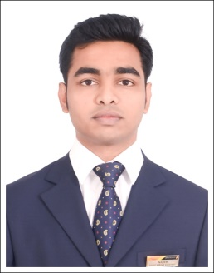
MOHAMMED

E-mail: MOHAMMED.374387@2freemail.com

Objective

Seeking a responsible and challenging position in an organization and looking forward to making a significant contribution in a company where I can effectively and dedicatedly apply my particular set of engineering,management skills and experience.

Experience

Iam currently working in jet airways (I)Ltd.
Designation: Customer Service Assistant (From July 2016 to At Present)
Company: Jet Airways (I)Ltd.
Ref : Sunder Rajan (Duty Manager)

Primary Responsibilities:-

- Providing efficient guest service and optimize revenue.
- Performing various customer service functions at the airport (check-in / boarding gate and ramp).
- Performing allocation assigned as per the roster.
- Checking status of all flights including catering uplift and adjust as required.
- Handling special situations and conditions.eg:Flight disruption / cancellation / overbooking.
- Carrying-out the upgrades according to the guidelines in respect of overbooking.
- Personally dealing with denied boarded and off- loaded guests, irate guests on exceptional basis.
- Ensuring safe / efficient operation of all activities at the Airport.
- Ensuring all ground handling activities are conducted as per Airline standards and policies.

Educational Qualifications

Degree | Institute | Year
Bachelor Of Aeronautical Engineering  Quality assurance and quality control | Noorul Islam University, India  Decibel institute,india | 2011-16  2015

Academic Projects Undertaken

- TGA,NDT and GAIN determination of graphite filled epoxy glass fiber .

Scope:
- In the 21st century,high strength,light weght energy efficient materials have received extensive attention.
- Metal matrix composites due to their heterogeneous composition,provide unlimited possibilities of deriving any characteristic material behavior.

2) Characteristics of tube hydroforming.

Skill Set

- Excellent communication and interpersonal skills.
- Work well with any environment and adopt accordingly.
- Positive attitude and ability to grasp quickly
- Ability to work effectively and independently.
- Ability to abstract ideas and to learn and develop new skills.

Computer Knowledge

- Office Packages :Word, Excel, PowerPoint, Outlook, Internet and Email
- Windows™ :XP, 7, 8, 8.1

Personal Details

Date of Birth: 23-05-1993

Marital Status: Single

Nationality: Indian

Languages: English, Malayalam, Tamil,Hindi,Arabic(basic)

I do hereby declare that the above mentioned details are true to the best of my knowledge and belief.

