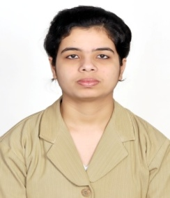
RESUME

Sharmili
Sharmili.374395@2freemail.com

_____________________________________________________________________

Objective:
A challenging position in a professional organization which can enhance my skills & strength in conjunction with company’s goals & objectives.

Work Experience:

Thomson Reuters International Services Private Limited – Bangalore (India)
Associate Content Analyst – Finance

Process : Estimation of shares of different companies

Designation : Associate Content Analyst

Experience : 1.9 year of experience in Thomson Reuters (October 2015– July 2017)

Award : Raising Star of month award for achieving 98% of productivity with zero
Errors.

Professional qualification:

Qualification | Institution Name | University/ Board | Year | Percentage
MBA | IBMR IPS Academy, Indore | DAVV | 2014 | 63%
BBA | Rajiv Gandhi Computer College, Satna | APSU | 2012 | 78.80%
12th | V.I.P. Campion Higher Secondary School, Satna | MPBSE | 2009 | 61%
10th | V.I.P. Campion Higher Secondary School, Satna | MPBSE | 2007 | 73.80%

Technical Skill:
- Certified in Advance Excel.
- Certified in Visual Basics Application.

Summer Training:
- 45day’s training at Bull’s Eye Institute in Operation & Marketing Department.

Projects:
- “A Comparative Study of Financial Statement of ICICI Bank & HDFC Bank through Ratio Analysis”.
- “Study on Women Empowerment through Microfinance”
(With special reference to Anupama Education Society in Satna city).

Seminar Attended:
- Women’s empowerment seminar by Dr. Kiran Bedi.
- International Management Conclave.

Certification:
- on basics of Stock Market Training by Bull’s Eye Institute of Training Indore (M.P)

Curricular Activities:
- Winner in add-mad show.
- Winner in street bazaar.
- Participated in poster presentation.

Personal profile:
- Date of birth :14-09-1992
- Strength : Positive attitude, Grasping power & Keen to learn new aaaaaaaaaaaaaaaa things.

- Nationality : Indian
Place: Dubai (UAE)
Date: 13-Nov-2017 Sharmili

