RAJESHKUMAR

Email: RAJESHKUMAR.374400@2freemail.com

Dear sir /Madam,

I would like to introduce myself, I am RAJESHKUMAR, BE-EEE Engineer holder and two year experience as ELECTRICAL ENGINEER (HV/LV/MEP) in Steel Rolling Mill Tmt Rod & Angles Manufacturing and Maintenance.

Now I am looking for job opportunity in Dubai UAE.

I have confident, I will prove to be a valuable addition to my concern. I understand that working for your organization requires and providing my better performance with my best of knowledge and experience in various departments.

So, I would welcome an opportunity to speak with you to prove my valuable performance and to meet your requirement.

I hope your favorable reply soon.

Note: Attached My CV below.

Thanking you,

Sincerely,

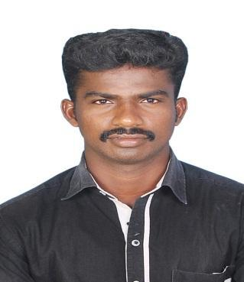

RAJESHKUMAR

TAMILNADU, INDIA.

Email:
RAJESHKUMAR.374400@2freemail.com

Date of Birth
Sex / Age
Marital Status Nationality Mother Tongue Language
Qualification

: 20th May 1992

: Male / 25

: Single

: Indian

: Tamil
: English & Tamil

: BE.,

APPLYING FOR THE POST ELECTRICAL ENGINEER

CARRIER OBJECTIVE:

Looking forward to secure a position in the field of electrical maintenance that would entrust me to apply the design and problems solving skills to assist in the designing of electrical components.

HIGHLIGHTS:

- Electrical distribution HT/LT/DC and control system

- Motor control and Power Management

- Control instrumentation allied with electrical controls

- Electrical wiring or Panel upgrade

ACCOMPLISHMENTS:

- Led new product management team that designed and developed the biggest cost saving project in company history.
- Co-ordinate new product induction activities, resulting in samples for management documentation.
- Wrote and edited document to keep staff informed on policies and procedure.

- Rep Led new product management team that designed and developed the biggest cost saving project in company history.

WORKING EXPERIENCE:

ELECTRICAL ENGINEER

CHERAN STEEL ROLLING MILL PVT LTD, COIMBATORE. TAMILNADU. INDIA.
(2011 – 2012) & (2016 – 2017)

Operation and Maintenance of Transformer, Air Compressors, Steam boilers and all electrical plant equipment.
Control instrumentation allied with electrical controls
Electrical distribution HT/LT/DC and control system
Involved in Electrical and HVAC system and Maintenance activities for factory plant
Handling the all Electrical works, HVAC & Plumbing
Motor control and power management
Electrical switches outlets and fixtures- install and repair
Design Heating and lighting protection install and repair

Electrical for home addition remodel
Home security Alarm repair and install
Finalization of design and technical requirements

Complete daily maintenance and repair logs,

Communicate with operators from other shifts,

Maintain and secure work tools

Clean and maintain work area, other duties as assigned

EDUCATION:

BE in ELECTRICAL ENGINEERING (2012 – 2016)

KLN College of Information Technology, Sivagangai. Tamilnadu. India.

ITI in ELECTRICIAN (2009 – 2011)
MAVMS I.T.I, Madurai. Tamilnadu. India.

Computer Proficiency:

Certificate Course in PLC (PROGRAMMABLE LOGIC CONTROLLER)

TAMILNADU POLYTECHNIC COLLEGE, Madurai. Tamilnadu. India

Declaration:

I hereby declare the above mentioned information is correct up to my knowledge and will be solely responsible for any discrepancy found in them

