SYED
SYED.374401@2freemail.com 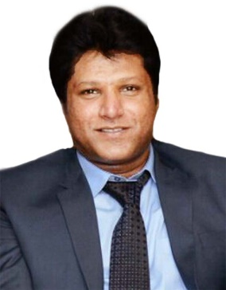

Objective: To work in pragmatic way in an organization where I can show my talent and enhance my skills to meet company goals and objective with full integrity and zest.

- ACADEMIC JOURNEY:
Intermediate

- FIELD OF SECURITY:

- Spin Dubai Club, Wafi Mall:
As a bouncer

- Music Room, Majestic Hotel:
As a bouncer

- Century Club:
As a bouncer

- Triology Club Madinat Jumairah:
As a Bouncer

EVENTS:
Work in events as a Security Supervisor
ROYAL MIRAGE HOTEL: 08-10-2010

- BURJ KHALIFA:
MISSION IMPOSSIBLE 4 SHOOTING

- RUGBY:
Worked as a Security Supervisor in Rugby 7
- SWIMMING:
Worked a s a Security Supervisor in Swimming Competition in Sheikh Hamdan Bin Rashid, Complex

- IBG HOTEL OPERATED BY MOVENPICK:
PAKISTAN & SIRILANKAN CRICKET TEAM

- MEDIA CITY WHAT'S ON AWARDS:
As a Security Supervisor

- DUBAI MALL NEW YEAR EVENT:
As a Security Supervisor

- ARABIAN CENTER:
On arrival of all team of Movie Race2

- PALM JUMERIRA OCEANA BEACH WEST 14 RESTAURANTS:
As a Security Supervisor

- COMPUTER SKILLS:
Have a Good Command on Computer.

- COMMUNICATION SKILLS:

- English
- Urdu
- Arabic (Beginner)

- PERSONAL INFORMATION:

- Date of Birth 06/May/1978
- Place of Birth Saudi Arabia (Dammam)
- Nationality Pakistani

Note: More than 7 years of experience in relevant field in Dubai UAE.

