Curriculam Vitae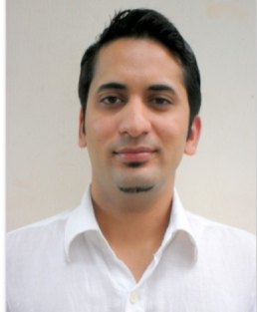
Ravikant
Ravikant.374410@2freemail.com

Carrer Objective
To be the part of a dedicated workforce of an organization that provides ample opportunities to learn and to contribute. Willing to work as key player in challenging and creative environment.
CAREER CHRONICLE

A keen learner with a Diploma in Hotel Management
Presently working in Tribe Hotel, Village Market Road Nairobi, Kenya
Possess ability to work under pressure & meet deadlines & deal with issues accurately & precisely.
Good communication and inter personal skills.Ability to complete projects within the assigned time & quality parameters.
Detail oriented with analytical bent of mind and positive attitude.

professional experience
- Presently working at Tribe Hotel, Village Market Road Nairobi ,Kenya as Master Chef from 18th july 2016 to till date.
- Worked at Imperial Clark’s Inn Dehradun Road,Uttarakhand (India) asC.D.P,5th September 2014 to25th May 2016
- Worked at Tandoor India Restaurant, 74/6 Hai Ba Trung., Ho Chi Minh City (Vietnam) since 27th September 2012to August 2014 As D.C.D.P
- Worked at Tandoori Nights,QuangNgai ,(Vietnam) Since 14th Oct. 2010 to 20thsep. 2012 As Commis I.
- The Gateway Hotel ,(Group of Taj Hotel) Chickmangalore (India), Since 10th May 2009 to 30th September 2010 AsCommisI.
- Hotel Kalinga Palace, Rajasthan(India), Since 19th August 2007 to 8th May 2009 As Commis II.
- Hotel Fortune,Jodhpur,Rajasthan(India), Since 7th August 2005 to 17thApril 2007 As Commis III.
- In Hotel GorbandhPalace (Unit Of HRH Of Hotels) Jaisalmer Rajasthan(India) has done Six MonthsJob Training.
- In Hotel Gorbandh Palace (Unit Of HRH Of Hotels) Jaisalmer Rajasthan(India) Since 20th Aug 2004 to 21st Jan 2005 ( Six Months) Training In Food & Beverage Production .

educational Qualification

- H.M (2004). With Ist division(77.3%) from Himachal Institute Of Hotel Management & Tourism
- Intermediate (2012) With IInddivision from U.P Board,
- High school (2004) With Ist division from U.P. Board,

computer skills

- M.S-Office, Internet.

Personal Profile

Date of Birth -11/May/1986
Language Known -Hindi, English, Garhwali& Vietnamese
Gender -Male
Nationality -Indian

Declaration

I hereby declare that all the information furnished above are true and correct to the best of my knowledge and belief.

Date
Place:

