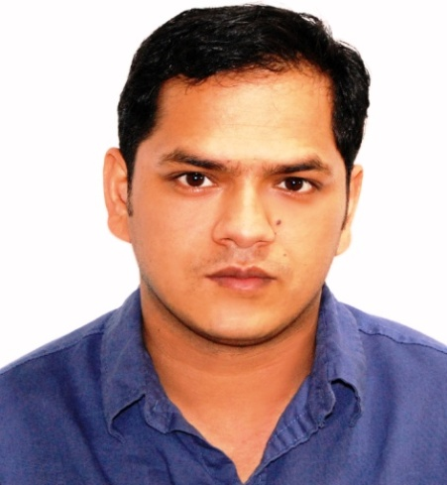
RAJESH
CALODYNE (MAURITIUS)
E-mail: Rajesh.374423@2freemail.com
_______________________________________________________
OBJECTIVE
To seek a challenging position is an esteemed organization to apply my technical,
Managerial and interpersonal skills and to become a dynamic and integral part of
the organization.
PROFESSIONAL EXPERIENCE
Zilwa attitude hotel (Mauritius)
Currently Woking at zilwa attitude hotel Mauritius as an Indian chef incharge,
(Oct 2015 to present)
Responsibilities:
- Incharge of an indian restaurant and all over indian food in hotel.
- Preopning expriance of indian restaurant.
- Managing and setting up the entire kitchen.
- Follow all safety and sanitation policies when handling food.
- Craeating the new Indian menu for restaurant and buffet.
- Works within the food cost budget always checks/adjusts food requisitions and controls waste.
- Training the staff for Indian cusine.
- Maintain the quality of the food item prepares and cook food according to recipe, quality standards and presentataion standards.
- Develop and maintain positive working relationship with staff member.

Hyatt Regency Dubai Creek Height (UAE)
Hyatt Regency Dubai Creek (pre-opening) as a chef de partie
(Dec 2014 to Oct 2015) events main kitchen,
Responsibilities:
- Team member of pre-opning hotel hyatt regency dubai creek.
- Responsible of Indian curry and tandoor.
- Managing and setting up the entire Kitchen
- Assist Chef de cuisine on proposing an Indian Menu for buffet, ala carte and canteen.
- Responsible of Indian curry and tandoor.
- Training the commi chef.
- Deft in ensuring strict compliance to HACCP, cleanliness, hygiene, health and safety as per DUBAI MUNICIPALITY law.

Grand Hyatt Dubai (UAE)
Chef De Partie (01st Feb 2010 to 13th Dec 2014) Indian specialty Restaurant,
International buffet and live cooking, hot and cold.
Commi Chef (26thAug 2007 to 31st Jan 2010) Indian specialty Restaurant.
Responsibilities:
- Maintains all standard operational procedures (SOP) as set by the corporate office.
- Assures safe, quality food products and complete guest satisfaction.
- Instrumental in assuring the highest health, sanitation and safety standards necessary in food handling and overall galley cleanliness.
- Checks all assigned food outlets (restaurants, buffets, action stations, and food displays) for creativity, quality, cleanliness and food safety.
- Deft in ensuring strict compliance to HACCP, cleanliness, hygiene, health and safety as per DUBAI MUNICIPALITY law.
- Shares the overall responsibility of proper storing procedures, food orders, food cost, equipment, sanitation and hygiene with the Chef De Cuisine.
- Works within the food cost budget, always checks/adjusts food requisitions and controls waste.
- Assist the Outlet Chef on proposing a New Menu for promotions.
- UP date training plans and training of new team member for helping to train, develop and grow a kitchen staff.
- Special take care ALLERGIC GUEST FOOD and VEGAN GUEST FOOD.

The Taj Gateway Hotel, Surat (India)
Commi 2^{nd (}Feb 2007 to Aug 2007) events main kitchen.
Responsibilities:
- Responsible for checking Hygiene and Sanitize of Kitchen, Freezers and Walking.
- Responsible for Checking Daily mise-en-place based on Daily Basis Operation.
- Responsible in Maintaining Hygiene and Sanitation.
- Handling the Daily events through BEO.
- Preparing food as per standard of the company.

Old world Hospitality, (habitat center) New Delhi (India)
Commi 3rd (Dec 2005 to Feb 2007)
Responsibilities:
- Responsible for Tandoor and Indian curry.
- Responsible for checking Hygiene and Sanitize of Kitchen, Freezers and Walking.

Taj Residency Lucknow (India)
Commi 3rd (April 2004 to Oct 2005) events main kitchen)
Responsibilities:
- Responsible for checking Hygiene and Sanitize of Kitchen, Freezers and Walking.
- Handling the Daily events through BEO.
- Preparing food as per standard of the company.

Taj Residency Lucknow (India)
Apprentice chef (March 2001 to Feb 2004)
Responsibilities:
- Training in all kitchen departments (Banquet, room service, restaurants, cold section).
- Secures food supplies from storerooms and refrigerators.
- Under supervision, operates standard cooking equipment such as mixers,
Steamers, toasters, choppers, fryers, ovens and stoves.
- Participates in kitchen cleaning work, such as washing and cleaning equipment.

Specialties:
- Pre-opening
- Indian food (kebab, curry, tandoor, biryani, bread)
- Grill

Area of Expertise:
- Team management.
- High level of personal hygiene.
- Food and kitchen safety.
- Special event planning.
- Menu planning and creating new recipes, Control food wasting.
- Good experience of working on live cooking stations where guest dealing is a
part of the job as well. Chef’s here are in direct contact with the guests and preparing stuff exactly as per guest requirements and take feedback about food and service to improve our food and service standard.
Achievements:
- Departmental Trainer certificate from Grand Hyatt Dubai (U.A.E).
- Completed person in charge hygiene training from Johnson Diversey in Dubai (U.A.E).
- Received an award for Best Indian Food & Restaurant in Dubai in the year of 2008 from ahlan! Masala award.
- Contributed as Task Force member to the success of the Global Hyatt General Managers Meeting at Grand Hyatt Dubai in March 2008.

Hobbies:
Travel and learning about regional dishes and food production techniques all around
the world.
Qualification Educational
- Passed the H.S.C. Examination from H.P board Dharmsala in 1996 (India) .
- Passed the S.S.E Examination from H.P board Dharmsala in 1998 (India).
- Completed Three year apprenticeship from The Taj Residency Lucknow
- March 2001 to Feb 2004.
- Gained expertise in MS - Office, MS - Excel & Internet Explorer
Material Management system, iscala.
Personal Details:
Date of Birth 15th June1979
Nationality Indian
Civil status Married

Issue Date 30/07/2013
Expiry Date 29/07/2023
Permanant Address:
I hereby certify that the above information is true and correct to the best of my knowledge and belief.

