Muhammad
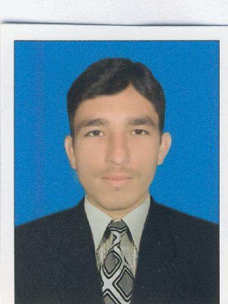
On three Months Visit Visa, here in UAE

Date of birth: December 10, 1990
Email: Muhammad.374425@2freemail.com

EDUCATION:
M.Sc - Agriculture Sciences: (2014-2016) GPA: 3.28/4.00
Major: Plant Breeding and Genetics

PMAS- Arid Agriculture University Rawalpindi, Department of Plant Breeding and Genetics

B.Sc- Agriculture Sciences: (2010-2014) GPA 3.69/4.00
Major: Plant Breeding and Genetics

The University of Agriculture, Peshawar, KPK, Pakistan, Department of Plant Breeding & Genetics

KEY SKILLS
Special abilities and skills:
- Ability to gather data, compiles information, and prepares reports.
- Ability to work effectively with a wide range of constituents in a diverse community.
- Ability to develop and deliver presentations.
- Ability to communicate properly in English, both orally and in writing.
- Strong interpersonal and communication skills.
- Willingness to learn, to perform & take on responsibilities and challenges.

PROFESSIONAL EXPERIENCE:
Hydroponics Engineer, with FOUR SEASONS GREENS, Nationwide distributors of tomatoes and other vegetables
Duration: 2011-12
The primary responsibilities of this position were, Arrangements of different designs, mixing of different growing mediums, making of nutrients solutions, Identification of diseases and their control. Additional activities included cooperative fieldwork and guide the farmers how to handle the soilless cultures.
Technical Supervisor in Pest Management, with Friends Environmental Solutions, country wide distributor of ALI AKBAR GROUP. Lahore, Pakistan
Duration: 2016-17
This position involved the inspection, location, identification and solving of pest problems in mostly skyscraper, restaurant, food plant and factory settings. Also visit to clients on regular basis.
Research Experience:

Morphological characterization of Brassica species collected at different ecological zones of Pakistan

This position involved daily inspection of Brassica field, noting all the changes taken place, data recording on daily basis, analyzing and interpreting the data to know the similarities and differences.
Brassica 260 genotypes were grown under field condition for morphological traits. The focus was on the shape and size of fruit.
Duration:6 months

Conferences & Workshops Attended:

Attended international 3-days workshop on “FOOD SECURITY AND SUSTAINIBILITY” at The university of Agriculture Peshawar, Pakistan.

Attended the Seminar on Tobacco crop, organized by Pakistan Tobacco company at PMAS- Arid Agriculture University, Rawalpindi

Awards Obtained:

1st Position in inter-school volley ball competition.

President of Sports Society (2015-2016),The University of Agriculture Peshawar, Pakistan.

Computer skills:

Microsoft word, Microsoft Excel and Power point.
Good in internet work as well
Excellent presentation maker.

Language Skills:

Excellent proficiency in English, Urdu (Fully Proficient, Advanced Level), Pashto (Fully Proficient, Advanced Level)

