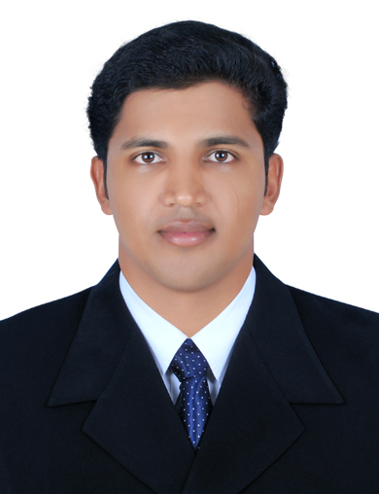
PRATHEESH

E-Mail: PRATHEESH.374427@2freemail.com

CAREER SUMMARY
An Engineer with 5 years and 5 months of experience in Heavy Machinery Installation, Maintenance and Repair project
- Currently working as Assistant Manager Product Support for Caterpillar Heavy Machinery.
- Over 5 years of professional experience in After sales – Service for Heavy Machinery.
- Implementing systems, processes & procedures to facilitate smooth functioning of Service Operations
- Product development & service support for equipment components
WORK EXPERIENCE

GMMCO LIMITED
Designation: Assistant Manager - (1st April 2015- Present)
Role: Product Support -Heavy Machinery
Responsibilities
- Reporting to Service Head and assisting in execution of New Business establishments
- Organizing and chairing meetings with Manufactures in resolving Executional and technical issues pertaining to all activities departments.
- Erection and commissioning of Heavy machinery
- Onsite repair and maintenance of
- Conducting technical audit and providing recommendations for improving product life and availability.
- Technical support to Site engineers as well as for customers during major breakdowns.
- Planning and effective utilization of inventory using FIFO analysis.
- Meeting customers, enhancing spares by planning and estimating the stock there by reducing lead time in procurement.
- Service contract planning, execution and Monitoring.
- Monitoring and reviewing on regular basis with all Projects/Branches on progress of Parts revenue, Service performance, outstanding limit, Collections on receivables and driving the branches to achieve their monthly Targets.
- Continuous monitoring of Field machines along with Service coordinators to generate opportunities for both Sales and Service.

GMMCO LIMITED
Designation: Senior Engineer (11 June 2012 to 1st April 2015)
Role: Customer support
Responsibilities
- Erection and Commissioning of Caterpillar Mining Trucks , Shoves and Draglines
- Maintenance of Caterpillar shovels, draglines and trucks
- Leading a team size of 100 plus technicians
- Planning and execution machine assembly activities
- Responsible for product delivery and quality.
- Site Supervision and project execution
- Heavy lifting , alignment of motors, welding and quality assurance
- Competent in liaising with Design Engineers for accomplishing activities like design clarifications,, etc.
- Responsible for service reports and product documentation for warranty support
ADDITIONAL SKILLS & TRAININGS
- Experience in working with cross cultural team.
- Attended Training of finance for managers conducted by Institute For Financial Management And Research
- Good knowledge in Non-Destructive Testing (Ultrasonic Test, Magnetic Particle Test, Radiographic Test)
- Microsoft Excel, Microsoft Power point, Microsoft Project, Microsoft Word.
- Handled a team of people within a short span of my career.
- Auto CAD 3D and Solid works
EDUCATION

- Bachelors in Mechanical Engineering from Amrita School of Engineering, Bangalore in 2012 with 6.67/10 CGPA
- Higher Secondary Schooling ,Government Higher Secondary School Kuttamath , Kerala ,2008,Over all Aggregate 80%
- SSLC, Government Higher Secondary School Kuttamath , Kerala,2006, Over all Aggregate 90%
ACHIEVEMENTS

- Executive Program In Business Administration (EPBA) From IIT Madras , 2016 with CGPA of 7.6/10
- Achieved record team achievement of exceptional contribution award towards outstanding team work and completing the project before time 2015- 2016
- Achieved record team achievement of exceptional contribution award towards Dragline Erection during 2014- 2015
PERSONAL DETAILS
Date of Birth | : 30th December 1990
Languages Known | : English. Hindi, Malayalam and Tamil

