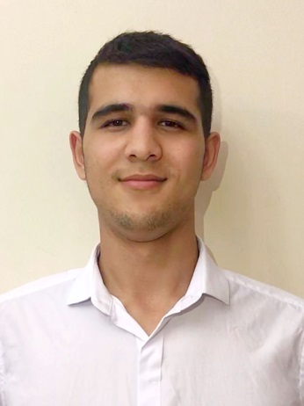
FAZOGIR
FAZOGIR.374443@2freemail.com

KEY QUALIFICATIONS:

  - 3+ years’ extensive experience working with renowned companies

- Flexible ,pleasant personality, courteous demeanor and neat appearance

- Bilingual: English and Russian and Tadjik

- Computer: MS Office and Excel , OPERA , Web developing (html,css,javascript)

RELEVANT EXPERTISE

- Greeting and interacting with customers in a professional manner

- Work with customers to find what they want

- Create solutions and ensure a smooth sales process

WORK EXPERIENCE

“XXI age boutique” Uzbekistan
Sales Representative
May 2014- September 2015

*Warmly greet customers and bid a tender departure and invite to visit again
* Able to speak in a friendly way to customers and potential customers, listening to their needs and helping communicate options for them.

“Samarqand Darvoza Mall” Uzbekistan

Costumer Service

October 2015- May 2016

* Speak to customers about a product's different features, and answer any questions they might have
* Directs visitors by maintaining employee and department directories; giving instructions.
* Building strong customer relations with existing clients.
“ZARA” in Tashkent, Uzbekistan

Sales Assistant

July 2016- October 2017

*Meeting and greeting customers

*Selling products by establishing contact and developing relationships with clients

*Contributing to team effort by accomplishing related results as needed.

CERTIFICATES

*IELTS (International English language testing system)

ADDITIONAL CAPABILITIES

*Excellent communication skills; able to give accurate information to costumers

*Outstanding phone etiquette

*Able to stand and walk for extended periods of time

Education

Secondary scool: Web developing 2014-2017 Uzbekistan Fergana

Language skills
 |  | Speaking | Reading | Listening | Writing
English |  | Fluent | Fluent | Fluent | Fluent
Russian |  | Fluent | Fluent | Fluent | Fluent
Uzbek |  | Native
Tadjik | Fluent |  | Fluent | Fluent | Fluent

Additional information

Permanent address Fergana, Uzbekistan

Marital status: Single

Visa Type: Visit visa

Nationality: Uzbekistan

I hereby certify that all the above information are true and correct to the best of my knowledge and belief.

