RESUME

PREETHY
PREETHY.374444@2freemail.com

ADDRESS –
Al Malas Cafeteria building, Al Qasmia, Sharjah, UAE.
GENDER- Female

NATIONALITY- Indian
MARITAL STATUS- Married
DOB- 16-07-1991
VISA EXPIRY – 28-07-2020

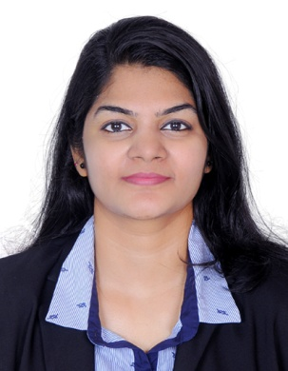

SUMMARY

Dedicated customer service representative who consistently meets and exceeds productivity goals. Maintains a high level of professionalism, patience and efficiency to minimize customer dissatisfaction and increase loyalty.

EDUCATIONAL QUALIFICATION

Month & Year of Passing | Examination Passed | Name of Board/ University | School/College Studied | %
May  2012 | Graduation  BBM with  Computer Application | Bharathiyar University | Sree Narayana Guru College of Arts & science, K.G.Chavadi, Coimbatore | 80%
March  2009 | Higher Secondary Education | Higher secondary  board | BSS Gurukulam Higher secondary school, Alathur | 80%
March  2007 | Secondary Education | Board of Public  Examinations | St pauls English medium high School, kollengode | 78%

COMPUTER KNOWLEDGE

OPERATING SYSTEM | Windows 98, Windows XP, Windows 7,  Windows 8
LANGUAGES AND PACKAGES | HTML, MS-Office
GUI | Visual Basic 6.0, Tally 9.1, SAP ERP 7.2,  MS Expenses, DMS, CRM & MS Audit.

EXPERIENCE

- Worked as Customer Relation Officer from September 2014 to July 2016 in SYBRID – Sharjah

KEY RESPONSIBILITIES:
- Answer calls, provide customer with product & service information.
- Handle customer inquiries and complaints.
- Enter new customer information into system.
- Update existing customer information.
- Process orders.
- Identify & escalate prioritized orders.
- Route calls to appropriate resource.
- Follow up customer calls where necessary.
- Document all call information according to Standard Operating Procedures.
- Research required information using available resources.
ACHIEVEMENTS
- Best Employee Award - January 2016.
- Quality Service Award - July 2015.
- Productivity Award - July 2015.

- Worked as Process Associate in Accounts Payable Department from January 2013 to June 2013- ACCENTURE- Chennai, India.

KEY RESPONSIBILITIES:

- Auditing and Query handling of expense reports of Microsoft (Client) employees.
- Handling customer and client queries and monitoring towards early closure of the tickets.
- Ensuring High quality and accuracy is maintained in every response sent to the Microsoft Employees.
- Master End to End process knowledge.
- Handling exceptional processing for India Subsidiaries
- Performing the reconciliation activity for the exceptional processing.
- Working independently on key areas and reduce dependency on supervisor’s input.
- Adhere to Company and Client Compliance & Policies.

- Worked as Junior Executive in online marketing services from October 2012 to December 2012- UGAM SOLUTIONS – Coimbatore, India
- Worked as Trainee Member with ACENET EDUCATION - Coimbatore, India from June 2012 to September 2012.
STRENGTHS

- Ability to build and maintain professional relationships.
- Ability to adapt new situation & technologies.
- Ability to analyze & solve problems/issues.
- Self -Motivated
- Team player.
- Good attitude.
- Excellent interpersonal skills.

DECLARATION

I hereby declare that the information furnished above is true to the best of my knowledge.

Preethy Prashobh
Place: Sharjah- UAE.

