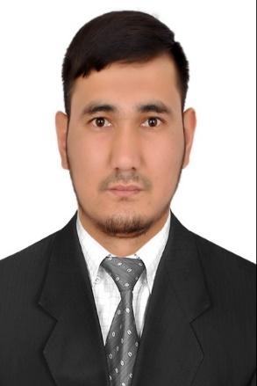
KAPARBEK

ABOUT ME
Date of birth: April 11-1987
Nationality : Kyrgyz Family Status: Married

EDUCATION
2003-2008 BISHKEK IN KYRGYZSTAN,ISLAMIC AND ARABIC Institution
1993-2003 Secondary school N-13
TOEFL Course (certificate)
English conversational course
Computer science
LANGUAGES
ENGLISH: FLUENT
RUSSIAN: NATIVE
ARABIC: FLUENT

Kaparbek.374445@2freemail.com
SUMMARY OF QUALIFICATIONS
Quality customer service and communication skills
Attention to details and excellent follow up
Strong verbal and personal communication skills.
Accuracy and attention to details.
Tolerant and flexible, adjusts to different situations.

WORK EXPERIENCE
“WORLD OF TEXTILE” Deira DUBAI
SALESMAN OCT- 2015-2016
- Greeting customer who inter the shop.
- Assisting shoppers to find the goods and products they are looking for
- Being responsible for processing cash and card payments.
- Keeping up to date with special promotions and putting up displays

“Mix Brand Fashion” Bishkek, Kyrgyzstan
Sales assistant Dec 2012-2014

- Advice and assist clients for legal, economic and market values.
- Analyze and research about market trends to know the competitive market prices.
- Collect and deliver the financial and required documents for clients.
“Dordoi Plaza” Bishkek Kyrgyzstan.
Salesman Nov 2009-2011

- Responding quickly and resourcefully to customer requests or concerns.
- Giving information to customer about products.
- Up selling and marking recommendation to customers.
- Receiving store deliveries.
REFERENCES AVAILABLE UPON REQUEST

