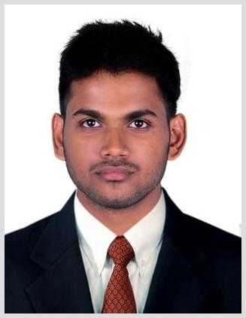Sachu
Sachu.374457@2freemail.com

Career Objective

Seeking an entry level position in a progressive concern whereby I can utilize my skills, abilities and potentials to the optimum.

Academic Qualification

- 2012-2016

Completed B.Tech in Mechanical Engineering from Nirmala College of Engineering,Chalakudy under Calicut university with a CGPA of 7.0.

- 2010 -2016

Complete plus two from SNHSS, Irinjalakuda under Kerala state board with 90%.

- 2010
Completed SSLC from JPEHS, Koorkenchery under Kerala state board with 88%.

Experience

- 2017 – Present

Working as Junior Engineer in JBM engineering, Pune

Training and Accomplishments

- 2016-2017

Completed training in Master of CAD/CAM from Central Tool Room and Training Center, Bhubaneswar.

- Journal Published on B.Tech Main project, titled “Design and Fabrication of Trenching Machine” in International Journal of Advanced Engineering and Global Technology Volume 4,Issue 2, March 2016

Projects Undertaken

B.Tech Mini Project:

Project Area: Manufacturing

Project Title: “Sand screening machine”

Software used: Solid Works 2011

B.Tech Main Project:

Project Area: Manufacturing

Project Title: “Fabrication of trenching machine”

Software used: Solid Works 2015

CTTC Project:

Project Area: Design and Manufacturing

Project Title: “Pneumatic Punching Machine”

Software used: Creo 3.0, ANSYS 15

Skills and Interests

Language Proficiency: | Software skills:
Malayalam[R/W/S], | Creo 3.0 | MS Office
English[R/W/S] | CATIA V5 R21
Hindi [R/W/S] | AutoCAD Mechanical 2015
Tamil [S] | Solid works 2016
 | UG NX 9.0
 | ANSYS 15

Declaration

I hereby declare that the above information’s are correct to the best of my belief and knowledge.

Place: SACHU

