PROFILE

WORK

EXPERIENCE

WORK

EXPERIENCE
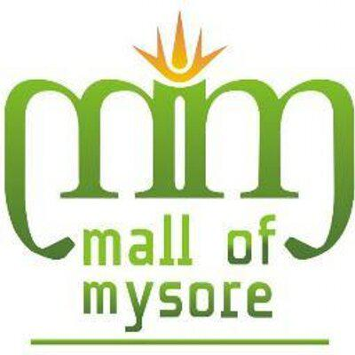

Sumanth

Branding & Communications Specialist

Sumanth.374458@2freemail.com

I am an experienced enterprising professional intending to continue my development as Branding and Communications specialist with keen interest in business development.

I think in terms of results and objectives, I am enthusiastic, and I work with decisiveness and conviction. I have a proactive attitude and find positive ways to stimulate and engage with people.

Branding & Communication Specialist | December 2015 - Present

International Modern Hospital LLC

RESPONSIBILITIES:

- Monitoring production of advertising copy and graphics to ensure total alignment with branding strategy and maximize effectiveness of media reports

- Effective media planning and buying including broadcast, outdoor, print and digital

- Evaluation of all creative pieces to ensure brand visibility

- Plan and publicize events including negotiating vendor contracts & designing promotional materials

ACHIEVEMENTS:

- Achieved 20% profitability by negotiating agency fees and contracts

- Achieved 10% growth in Hospital revenues by developing efficient marketing plans and planning creative marketing initiatives

- Executed Social media based marketing programs which resulted in 10% increase in sales, 50K likes , 10K Facebook fans & 10K unique email addresses

Assistant Marketing Manager | April 2013 - October 2015

Mall of Mysore

RESPONSIBILITIES:

- Analysing, developing and implementing various marketing strategies, annual budget plans, mall promotions, tenant relations, cross promotions and brand space management for Mall of Mysore under Harsons AR I Retail and Décor Ltd

- Generation of revenue through Promotional activities, branding and advertisement, visual merchandising, customer-retailer relationship strategies, logistics, brand activations and leasing

- Liaise with ad agencies, media partners and rationally decide on the best marketing requirements for the mall with most effective financials

ACHIEVEMENTS:

- Achieved 30% increase in footfalls for Mall of Mysore by organizing various promotional events, Shopping Festivals, Flea Markets and Brand activations

- Achieved 50% growth in revenues through external and internal branding, advertisements, addition of kiosks and various paid promotional activities

- Successfully organized workshops and fund raising activities for various disabled/ underprivileged associations’ by providing them basic necessities

CURRICULUM VITAE PAGE 1

WORK

EXPERIENCE

Sumanth

Branding & Communications Specialist

Brand Analyst / Evaluator Trainee | August 2009 – September 2010 Repucom Media International Pvt Ltd |India

RESPONSIBILITIES:

- Worked as an analyst for the company’s US, Singapore and India division which included sports such as Nascar, NFL, Cricket and Golf, here we calculated 'Sponsorship viability' and 'Return on Investment' for the sponsors. This was done by tracking all brands and sorting them in terms of screen time, visibility and repetition on proprietary tools.

- Additionally contributed to the internal reporting and audit team by creating and maintaining Excel and Power Point based reports of internal workflow database and made presentations to higher management in India and Australia.

ACHIEVEMENTS:

- Achieved expertise in cricket brand analysis and played a vital role to form a separate team for sports which focused on world games in addition to US specific ones

- Awarded employee of the year 2010 for generating best hit rate in the game of cricket

PROFESSIONAL | • A high standard of professionalism in my work
ATTRIBUTES | • The ability to remain calm and objective in all situations
 | • The ability to quickly identify and resolve client problems
 | • Able to work autonomously and in a team environment
 | • A good sense of humour

EDUCATION | Master’s in Business Administration | 2010 - 2012
 | MS Ramaiah Institute of Technology, India
 | Bachelors in Commerce | 2006 - 2009
 | Mysore Education Society, India

PERSONAL | Nationality | : | Indian
DETAILS
 | Visa Status | : | Employee Visa
 | Date of Birth | : | 18 April, 1988

CORE SKILLS | ● | Excellent Communication | ● | Team Player
 | ● | Multi-tasker | ● | Target Driven
 | ● | Attention to Detail | ● | Ability to Prioritize

_{REFERENCES} Available on request.

CURRICULUM VITAE PAGE 2

