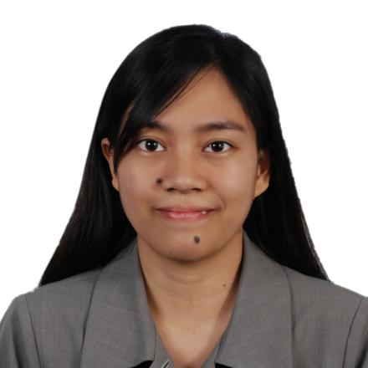
Remedios
Remedios.374478@2freemail.com
RP Certified Public Accountant

Summary of Qualifications
A recent CPA exam passer seeking to leverage accounting skills and knowledge to gain an accounting position at your firm. Dedicated, eager to learn, competent, fast-learner, detail-oriented individual with the capacity to go beyond what is expected and achieve company goals.

Work Experience
Fratelli Business Care – Accounting Firm, Philippines
Accounting Intern, February 2015 – April 2015 (3mos.)
- Shadowing members of the Accounting Team as they perform their duties and Assisting in day by day accounting task.
- Assisting with research, filing, data entry, and recording and maintaining accurate and complete financial records.
- Assisting in the preparation of individual tax return and remitting tax payments to accredited agent banks.
- Handling sensitive or confidential information with honesty and integrity.
- Learning how to work as part of the Accounting team to compile and analyse data, track information, and support the company or clients.
- Taking on additional tasks or projects to learn more about accounting and office operations.

Nidec Subic Philippines, Inc. – Electronics Manufacturing Company, Philippines
(under Powerlane Resources, Inc.)
Timekeeper, February 2012 – October 2012 (9mos.)
- Reviewing 1600 employees departmental timecards to ensure employee’s time is accurately recorded and complete.
- Compiling and preparing of summary reports of employee official business and other payroll related reports.
- Assisting supervisors with questions regarding their employee’s timecard.
- Reviewing and making necessary corrections in regards to the Leave reconciliation error report.
- Support in month-end inventory checking.

Education
- Mondriaan Aura College, Philippines
- Bachelor of Science in Accountancy, 2016
- Bachelor of Science in Accounting Technology, 2015
Certifications and Licenses
- Certified Public Accountant –Philippines (License No.)
Technical Skills
- Proficient in MS Word, Excel, PowerPoint
- Xero
- Knowledge of Generally Accepted Accounting Principles (GAAP)
- IT knowledge/Computer Skills
Core Competencies
- Planning and organizing
- Communication skills
- Problem analysis and resolution
- Decision-making
- Attention to detail
- Resourceful
Personal Data
Age : 24 years of age
Place of Birth : Olongapo City, Philippines
Citizenship : Filipino
Gender : Female
Civil Status : Single
Language Spoken : Tagalog, English
Visa Status : Tourist Visa
Religion : Christianity

I hereby certify that the above information are true and correct to the best of my knowledge and belief.

