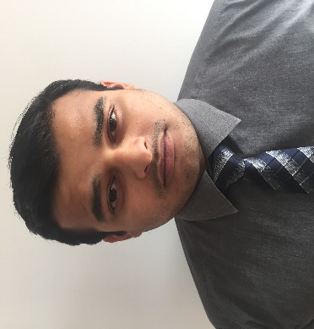
ALI.
ALI.374490@2freemail.com

CAREER OBJECTIVEs:

Challenging position in a growth-oriented organization,where I can prove my skills and computer knowledge to its optimum, not only to perform my assigned duties well but also to further enhance my skills in an environment,which offers ample opportunity to groom my personality as well.

Summary Of qualification:

Dedicated and self-motivated individual offering a solid educational background in Commerce, Strong multi-tasking abilities,Work well both independently and as a contributing member of the team.

SUMMARY OF ACADEMIC QUALIFICATION:

- Master in Business Administration (MBA-2017)
University of Education
- Bachelor of Commerce (B.Com-2012)
University of the Punjab Lahore
- Higher Secondary School Certificate (I.Com-2010)
Board of Intermediate and Secondary Education Lahore

WORK EXPERIENCE

- Working in Al Jazeera (Channel partner of Etisalat) as a Sales Increasing Marketer.
May 2017 – Present

This company is active in sales and distribution of Etisalat internet services in all over UAE
I am responsible for:
-Incresing sales for company benefit
-To develop company reputation among the market
- Kauser Automobiles (pvt) LTD as a Sales Increasing Marketer
Feb 2015 – March 2017

This company is active in automobiles all over the Pakistan. This company is also active in manufacturing the spare parts for other automobiles companies. I was responsible for:
-Building and developing sales in Lahore
-Managing the network to achive the target.
-Monitoring the stock availability, orders and arrival.

- 4 months work experience in Shaigan Pharmaceutical Pvt. Ltd.
This company is active in pharmaceutical in pakitsan. This company provides medicines for for different deseases. I was responsible for:
- Check and maintain the availability of stock in assigned territory.

Computer Skills:

- Ms word
- Ms excel
- Power Point
- Internet browsing, searching etc.

Areas of Strength:

- Team Player
- Honest
- Hard Working
- Time Management Skills
- Ability to Work in Pressure
- Possesses Leadership Qualities
- Dedicated and Self Motivated
- Driven to Learn and Apply New Ideas

languages:
- English
- Urdu

Personal Detail

Date of Birth: 02 October 1992
Nationality: Pakistani
Marital Status: Single
Visa Stats: Residence Visa

Reference:

References will be furnished on demand.

