Email :--

AKHIL.374493@2freemail.com

Date of birth : 22.06.1991
Sex : Male
Marital Status : Single
Nationality : Indian

PASSPORT DETAILS

Date of Issue : 21.02.2017
Date of Expiry : 20.02.2027
Place of Issue : Trivandrum
VISA Status : Visiting Visa
Valid From : 29.10.2017
Valid Until : 23.01.2018

AKHIL
CERTIFIED MEDICAL CODER
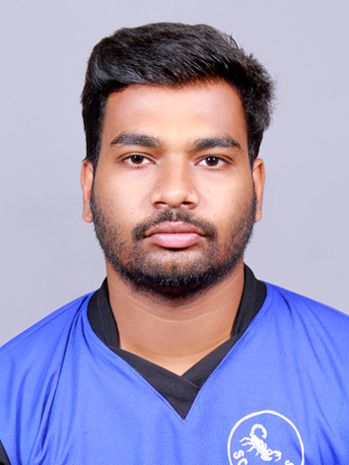

CAREER OBJECTIVE

Through constant learning, widen the horizon of my knowledge and achieve the best of abilities to develop my own acumen and sharpen my skills and utilize the same to the advantage of the organization and its surroundings. I am seeking role in a dynamic organization to contribute accrued expertise in charting a mutual growth path.

OVERVIEW& PROFFESIONAL EXPERIENCES

- Well organized, self motivated and hardworking medical/Insurance Coder.

- Worked as a Medical coder, with Navigant India private limited (previously Revenuemed India private limited Trivandrum India), from 15th May 2015 onwards.

EDUCATIONAL QUALIFICATIONS

- (Certified from (AAPC).

- B.Sc. Nursing
Board: Kerala University of Health Science
Sree Gokulam Nursing College, TVPM.

- Plus Two
Board: Board of Higher Secondary Kerala
C.P. H.S.S, Kuttikkadu, Kadakkal, Kollam

- SSLC
Board: Board of public Examination, Kerala
MMHSS, Nilamel, Kollam

NATURE AND RESPONSIBILITY OF WORK

- Medical coding E/M, ICD 10, CPT, HCPCS
- Outpatient and ER files coding.
- Documenting patient history and record making
- Assigning proper diagnosis and procedure codes

OUTPATIENT CODING KNOWLEDGE

- Expertise in medical record review to abstract information required to support accurate outpatient coding.

- Expertise in assigning accurate ICD-10 medical codes for diagnoses and procedures performed in the outpatient setting.

- Solid understanding of anatomy, physiology, and medical terminology required to correctly code facility services and diagnoses.

- Understanding of outpatient reimbursement methodologies (OPPS)

PROFESSIONAL LICENCES

CERTIFIED OUTPATIENT CODER (AAPC)

MEMBERSHIP ID:

LANGUAGES KNOWN

English, Hindi, Malayalam & Tamil.

SPECIALIZED AND EXPERIENCED AREAS

- Outpatient coding, Emergency, Evaluation and management, ancillary and radiology coding.

- Perform audit coding of disease and injury diagnoses, acuity of care, and procedures.

- Knowledge of medical terminology, anatomy, physiology and pharmacology

- Assure the assignment of complete, accurate, timely and consistent codes by the medical coding unit.

- Extensive use of 3M and Encoder pro.

- Highly experienced in performing coder duties pertinent to the current International Classification of Diseases (ICD)-10, clinical Modification; American Medical Association Physicians’ current Procedural Terminology (CPT)-4; Health Care Common Procedure Coding System (HCPCS); Physicians ‘Desk Reference.

- Broad medical experience also includes billing, reimbursement, HIPAA rules, insurance verification, scheduling, and report creation

- Review and abstract relevant clinical data/medical records to select and sequence the appropriate ICD-10 CM diagnosis.

- Tutors new coders for compliance with ICD-10, classification systems and coding, regulatory guidelines.

- Strong proficiency of physician coding in and outpatient for the medical centre

- Responsible for handling different types of medical claims

SOFTWARE SKILLS

- 3M, MEDITECH, Trucode
- MS- WORD, MS-EXCEL and Internet Operation.

STRENGTHS

- Optimistic and Smart Worker

- Adaptability to change

- Strong analytical and problem solving skills

- Versatile & performance driven personality

- Good communication skill

- Quick learner and Go getter

- People Management & Leadership Skills

WORK PROFILE

- Coding the patient documents by following the proper guidelines using the software’s like 3M, MEDITECH.

- Assigning codes with highest specificity.

- Maintaining quality without compromising the quantity of work.

I hereby declare that the above information provided by me is true to the best of my knowledge and belief. I assure you my hard work, dedication, sincerity and commitment to deliver the valuable and successful medical services to your organization.

Place : India
Date :

.

