SADHIK,​ B.Com, MBA.,(Residing at UAE) 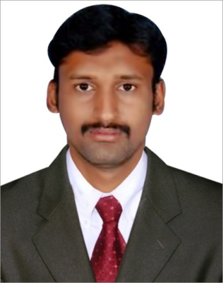
E-mail- SADHIK.374498@2freemail.com

Total Experience - 3 years
___________________________________________________________________________

Objective: ​Seeking a challenging position in your esteemed organization where my technical liaison and coordination skills can be effectively utilized to improve operations and contribute to the company’s growth.

Personal Skills:

- Good verbal and written communication skills

- Ability to work hard

- Ability to build motivation

- Creative & self-confident

- Positive approach thinking

WORK EXPERIENCE:

Company: Faham International FZE, Jebel Ali, Dubai, UAE

Experience: From 03rd Oct 2015 – 03rd May 2017.

- Project Organizing.
- Administration.

- Invoice Preparation, Orders issue for Production.

- Weekly Production Reports & Supervising.

- Conduct Weekly Meeting about Production.

- Arrange Shipments.

- Stock Report Maintain.

Job Designation: Accountant cum Administration In Charge.

Company: ​Kartik Homes Construction Company​.Chennai
Experience: From 08​^{th​}Aug 2014 – 12​^{th​}Sep 2015.

➢ Managing Accounts.
- Supervising & Motivate Employees to do Work Efficiently.

Job Designation: Accountant & Supervising.
Educational Qualification:

- Master of Business Administration at Indra Ganesan College of Engg in the year 2014 (CGPA -6.78%)

- Bachelor of Commerce​ at Jamal Mohammed College in the year 2012 (CGPA -6.10%)
- Passed Higher Secondary from Bishop Heber School, Trichy in 2009 (CGPA -68%)

- Passed SSLC from Bishop Heber School Trichy in the year 2007 (CGPA -68%)

SOFT SKILLS:

- Basic in computers.

- Operating systems.

- MS-Office.
- Basis in Tally.

Personal Details:
Date Of Birth : 24.06.1992
Sex |  | : Male
Marital Status |  | : Single
Nationality |  | : Indian
Language |  | : English & Tamil. Understanding Hindi
Hobbies |  | : Listening Music, Football.

Passport Details:
Date of Issue | : 12.08.2015
Date of Expiry | : 11.08.2025
Place of Issue | : Trichy.
,
DECLARATION :

The above mentioned information is true and correct to the best of my knowledge and belief. If I am selected and given a chance to serve in your esteemed organization, I shall prove my best and ability to the entire satisfaction of my superiors.

