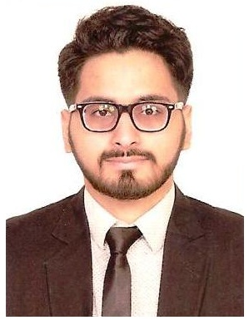
Abdul
Aerospace/Mechanical Engineer

Language: Fluent in English, Urdu & Hindi
Visa status: Visit Visa
Abdul.374508@2freemail.com
WHY ME:
- Economic and Commercial Acumen: Developed through ‘real world’ management modules undertaken throughout undergraduate programs and through exposure to CRM initiatives at work.
- Problem Solving and Project Management: Have project managed a range of tasks throughout my academic course coming up with business ideas, monitoring, evaluating and utilizing new methodologies. Especially during MSc Management as one module involved setting up a start up business. My group business idea made the most profit amongst the all the group.
- Team Work: Being an active member of team during my academic course working in a group projects and during my work experience has developed my personal and communication skills, as well as enhancing leadership and teamwork skills.
- Design Skills: Working on a range of university Design projects and implementing knowledge in practice has equipped me with new design skills using Solidworks and Abaqus. Using Solidworks, help demonstrate the application and how it would function. Using CAD also provided my productivity as it translated into fast designing and low cost and shorter completion time.
- Time Management: Gantt chart helped illustrate the start and finish dates of the terminal elements and summary elements of a project which led to displaying time management and multi-tasking abilities by simultaneously balancing academic commitments with part time job while not compromising results.
- Computing and I.T: Competent in MS Office, C/C++ programming, Matlab, Labview, Computational Fluid Dynamics and Finite Element Analysis.

AREAS OF EXPERTISE:

- Aircraft Design
- Engineering Dynamics & Structures
- System Engineering
- Strategic Management
- Project Management
- Quality control
- Project Managment
- Computational Fluid Dynamics
- Finite Element Analysis
- Fracture Mechanics
- Solid Works
- Internal Combustion Engines
- Strategic thinker
- Propulsion
- SWOT analysis
- Finance
- Lean manufacturing
- Project Management
- C/C++
- Lean manufacturing
- Microsoft office

WORK EXPERIENCE:

February2017 – October 2017
Aerospace Design Assistant engineer INTEGRATED DYNAMICS
Responsible
- For assisting students on their projects report.
- For providing assisting & consultancy on the design.
- To minimize the machine breakdown time.
- For providing assisting the installation of new equipment.
- For the inspection of new equipment.
- To give daily troubleshooting Report to Management
June 2016 – September 2016
Test Service Data intern Allstate Northern Ireland
- Dealt with provisioning data for the development
- Testing of the various software products developed in-house to supports its operations.
- Developed new methods implementing new techniques as lean IT.
- Improve the overall inefficiencies of the team by eliminating waste.
- Analyzing, collecting and providing the customers the data they required for customers business using different software.
Project Completed

- Final year project: Heat Transfer Canopy for High Speed Biaxial Testing

- Preliminary design of an aircraft for the BMFA 2015 University and Schools Payload Challenge.

- Finite Element Analysis Beam Analysis Project.

Professional Membership

- Student member of American Institute of Aeronautics and Astronauts.
Education:
2015-2016
Ulster University (United Kingdom) Master of Science in Management
2012-2015
Queen’s University Belfast (United Kingdom) Bachelor of Engineering in Aerospace

