Resume
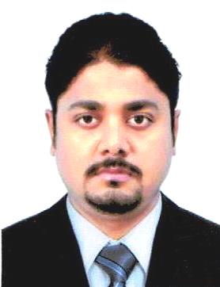
Vinayan
Vinayan.374513@2freemail.com

Career Objective
Seeking a position in a reputable organization which provides me the opportunity to explore my potentialities and talents and looking for a suitable position in the area of customer relationship & Management.
Professional Experience

- Organization : Printex Media Solutions Pvt. Ltd
Position : Office executive
Duration : February 2004 to March 2005

- Organization : Kottakkal Ayurveda Bhavan- Ayurveda
Paramedical Institute
Position : Managing Director
Duration : 17th April 2005 to 15th January 2009

- Organization : KottakkalAyurvedic Centre
Position : Supervisor
Duration : 28thJanuary 2009 to 27th January 2011

- Organization : Bajaj Auto Finance
Position : Sales DMA
Duration : 24th August 2011 to 31st October 2014

- Organization : KVR Automobiles,Kottakkal
Position : Manager
Duration : 17th October 2014 to 25th November 2016

- Organization : 3G Digital World
Position : Store Manager, Kottakkal
Duration : 7th December 2016 to 6th July 2017

- Organization : Cipher Crafts –The Complete Mobile & IT Solutions
Position : Administrator, Kottakkal
Duration : 21st July 2017 to 5th November 2017

Educational Qualification

Course | Board\ University | Year
S.S.L.C | Board of Public Examination, Kerala | 1998
Plus Two | Higher Secondary Board of Examination, Kerala | 1999
B.A Malayalam | University of Calicut | 2003
Diploma In Computer Application | Rukronix,KeralaGovt.Approved | 2013

Computer Knowledge

- DCA Passed with First Class
- Knowledge of Computer Hardware
- Knowledge of Computer Software
- Proficiency in Microsoft Office
- Internet

Co-curricular Activities

Participate in the service activities of a Youth Club.
Active member of religious oriented service organization.

Hobbies

Listening to music
Travelling
Reading

Personal Profile

Date of Birth : 27th May 1982
Sex : Male
Marital Status : Married
Nationality : Indian

Languages Known

Language | Read | Write | Speak
English | Yes | Yes | Yes
Hindi | Yes | Yes | Yes
Tamil | No | No | Yes
Arabic | No | No | Yes
Malayalam | Yes | Yes | Yes

Declaration

I hereby declare that all the above given information are correct and true to the best of my knowledge and if I selected I will discharge my duties and responsibilities to the entire satisfaction of my superiors.

