Fayaz

COVER LETTER

Dear Sir/Madam,

It is with a great pleasure that I would like to apply for the position, in your reputed company. If you are currently seeking a motivated, experienced individual to company's positions then kindly consider my qualification and work experience.

I believe I can make a positive contribution in your organization with my rich and varied exposure of over 5 years to the entire gamut of activities involved in Sales operations, Team Management, Etc

If you are searching for a dependable, results oriented professional with a solid performance track, I would be interested in speaking with you to discuss the value that my strengths and expertise can bring to your search. I can be reached in confidence through the below contact number or email address and look forward to hearing from you.

Regards,

Fayaz

Email: fayaz.374514@2freemail.com
FAYAZ
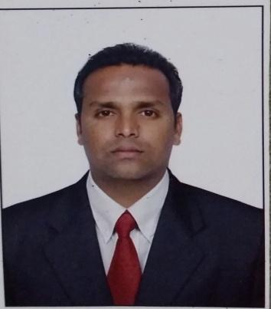
Email – fayaz.374514@2freemail.com
B.COM Honors from Karnataka University

Five years of experience in Sales & Retail Marketing

CAREER OBJECTIVES

To obtain a position that will enable me to use my strong organizational skills, educational background and ability to work well with people. Seeking a management position with leadership responsibilities including problem solving, planning and organizing.

CAREER PROFILE

A creative, enthusiastic, high–achieving professional Sales person with Over Five years proven

sales experience currently serving a leading NBFC in DUNIA FINANCE managing and maintain a RETAIL & DIRECT Sales in ALL PRODUCTS DEPARTMENT .

EMPLOYMENT HISTORY

Dunia Finance (Pact Employment services)
Relationship officer

Credit cards & personal loans & Auto Loans Dubai

September– 2017 to Till Date

Job profile:

Maintaining and uplifting the productivity through retail call and promotions.
Launching the different Scheme in retail leads to respective department of the branches

Developing strong relationship with existing customer and new customer for referrals leads and self-generated leads through telecalling .

Making daily sales report.

Strived on good customer relationship to ensure steady business.
Made service quality calls to the customer to ensure maximum customers satisfaction.

Tata capital financial services ltd
Team Leader (Auto Loans) Hubli - India
Credit Analyst & Sales
December– 2016 to Sep 2017

Job profile:

- Analyzing bank statement and audited financials of companies and individuals.

- Making sure that company meets policy parameters

- Assessing credit worthiness of companies
- Drive sales Team

    - Maintaining and uplifting the productivity through retail call and promotions.
    - Launching the different Scheme in retail leads to respective department of the branches

    - Developing strong relationship with existing customer and new customer for referrals leads

  - Making daily sales report.
  - Review and analyze the most effective dealers.

    - Made service quality calls to the customer to ensure maximum customers satisfaction.

Reliance World

Store Manager Hubli – India

May– 2012 to Oct - 2016
Job profile:

- Provide quality supervision and support to team members

- Identify training needs and provide feedback to the training team
- Launching the different Scheme in retail leads to respective department of the branch.

- Retain and develop talent
- Drive the use digital assets to enhance the customer experience

- Review and analyze the most effective customers Needs
- Be on the shop floor

- Maintain a luxury environment , ensure excellent execution and maintenance of visual merchandising guidelines across the store
- Made service quality calls to the customer to ensure maximum customers satisfaction.
- Lead , inspire and manage a high performing , positive store team

Educational qualification

Bachelor of Commerce (Accounts Hons) from Karnataka University in 2012 from

Karnataka- India

Computer Proficiency

MS-Word MS-Excel Power Point& Internet.

Personality Profile

Smart working and result oriented, loyal and honest Abilities to create and maintain relationships.

Willingness to learn and adapt the culture of the organization. Capabilities to deal inside and outside of the organization.

Strong analytical Inter-Personal and decision making skills.

Skills to understand problems and derive solutions, based on the facts. Enjoy face new challenges, ability to grasp very fast.

Dynamic, self-motivated and committed with leadership qualities.

Ability to make decisions and manage workload independently.

Posse’s good written and verbal communication skills, with an ability to work in any environment and to achieve deadlines and goals

Have the ability to become future leader.

Hobbies

Listening music, Traveling and playing Cricket

Personal Details

Date of Birth | : | 03 June 1989
Mobility | : | Anywhere across the world.
Marital status | : | Married
Nationality | : | Indian
Language Known | : | English , Hindi , Urdu ,Kannada , Telgu

Passport Details:
Passport No | : | M7892515
Place of Issue | : | Bangalore –India
Date of Expiry | : | 05/04/2025

Place : DUBAI ( Fayaz)

