Admin/Reception/Customer Service
Address: Dubai, U.A.E

Email: errol.374518@2freemail.com Visa: Cancelled Visa

PROFILE

To presume a challenging career within dynamic organization which offers a positive work environment, providing an opportunity for professional growth and competencies in working in a fast paced multicultural environment.

WORK EXPERIENCE

Essential Duties and Responsibilities include, but are not limited to the following. Other duties may be assigned.

Company:

Sternon Real Estate (Developers, Builders and Promoters)
Address:

Dubai UAE
Position:
Administrative

Receptionist

Work Period

July 11, 2015 – September 20, 2017

- Providing professional reception service to clients and visitors

- Communicate verbally and in writing to answer inquiries and provide information.

- Carrying administrative duties such as filing, typing, copying, binding, scanning etc.

- Arrange and confirm appointments.

- Organize and coordinate meetings and conferences.

- Set up and maintain filing systems for various documents and records.

- Processing Accounts (Bank Works, Bank Statements, Cash Statements, Ledgers, and Invoices) and monthly WPS for employees.

- Maintaining the cleanliness and orderliness of the office and monitoring and purchasing general office supplies and pantry requirements regularly.

- Review deliveries against the orders and deal with non- supplied, under orders, over orders and damaged goods.

- Arrange for Couriers or Pick up within and outside UAE.

- Responsible for calling and arranging interviews for hiring candidates.

- Organizing travel arrangements for senior managers.

- Carry out any other duties, as assign or requested within general areas of responsibility and grade of this post.

Company:

PAGCOR (Philippine Amusement and Gaming Corporation)
Address:

Hyatt Branch Manila, Philippines

Position:
VIP Bar Clerk

Work Period

October 20, 2014 – April 1, 2015

Company:

Aventus Medical Care, Inc.

Address:
Makati, Philippines

Position:

Registered Nurse/ Medical Records Processing Staff
Work Period:
March 25, 2013-

August 25, 2014

- Securing and developing all records, equipment, and programs related to Clerical Works.

- Providing information to customers by verifying and understanding request.

- Maintains daily records of items as per the invoices received daily from staffs.

- Answer and transfer calls departmentally and outside calls.

- Knowledgeable in using equipment for Clerical works (Printer, Photocopier, Scanner, Mimeo machine)

- Reports weekly inventory with VIP Supervisor to maintain items stocks and countercheck with her inventory sheet.

- Reports weekly inventory with VIP Supervisor to maintain items stocks and countercheck with her inventory sheet.

❖ Maintain a client/ patient record that are well detailed and
correct, encoded to the company’s system.

- Demonstrate good clinical practice at all times and to be accountable for own actions.
- Ensure patients privacy and confidentiality.

- Carry out observations, investigations and treatments as required, including phlebotomy and ECG reading.

- Ensure equipment is in good working order

- Maintain accurate records of patient care.

- Organize tests and appointments both within and outside the hospital.

- Provide patients and families with information regarding the management of their condition.

- Ensure correct labeling and transport of specimens.

- Expediting of requested Patient’s Medical Record.

LICENSES

July 2012
- Red Cross Basic Life Support License 
- Red Cross Standard First Aid Training License 
March 2013
- American Heart Association Accredited Basic Life Support 
- American Heart Association Accredited in Advanced Cardiovascular Life Support 
May 2013
- Association of Nursing Service Administrators of the Philippines IV Therapy License 
 

EDUCATIONAL BACKGROUND

Course: Bachelor of Science in Nursing – Saint Jude College (April 2012)
Nursing Licensure Examination (Philippines) Passer of January 30, 2013
Awards:
 Certificate as Blood Committee

 Certificate of Winning as 3rd  Placer in Inter-Collegiate “Battle of the
Brains’” Quiz Bee

Short Course: Intermediate Caregiving- Filipino Institute Burjuman Branch (September 2016)
Awards:

- Top Student

SKILLS

- Microsoft Office: Word, Excel, Outlook, PowerPoint, Publisher
- Speed Typing Test: 189 CPM (38 WPM)

- Basic Photo Editing
- Brochure, Flyers and Tarpaulin Making
- Basic Knowledge in CorelDraw

- Under-Training of QuickBooks

 | PERSONAL INFORMATION
Citizenship: | Filipino
Civil Status: | Single
Languages: | English and
Date of Birth: | January 18, 1992

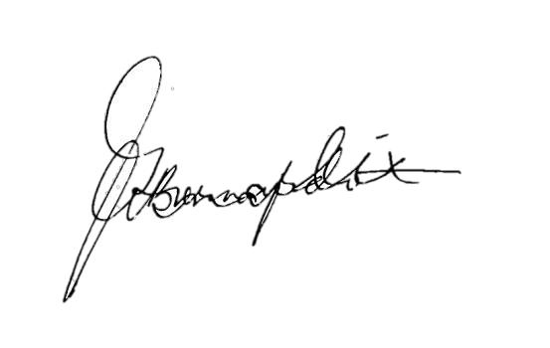
I hereby certify that all information stated above is true and correct based on my knowledge and belief. ;

Errol

