CURRICULAM VITAE
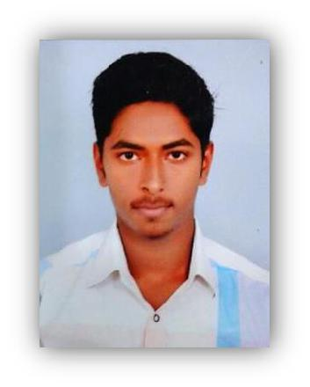

ABDUL
Email: Abdul.374539@2freemail.com

OBJECTIVE

Seeking a challenging career in a reputed organization and myself to be all Set for the industry.

CAREER SUMMARY

WORK EXPERIENCE

- DISTI INFO SYSTEMS, Kalpetta, Wayanad (Senior Technician – Maintenance) Designation : Computer Hardware and Networking Administration.

CCTV security system installation and troubleshooting. (October 2014 to September 2017)

Responsibilities in Maintenance:

- Installation of Windows 98,xp,7,8,8.1,10 etc…, and also Ubuntu

- Handled testing, periodic service maintenance checks and repairs of Computers and CCTV System including replacement of damaged parts and components

- Conducted monthly preventive maintenance test of all equipment.

- Document repairs for specific clients and kept logs for management’s reference, necessary in computation of overtime rendered and job request accomplishments.

- Maintenance and troubleshooting of Network configuration, Server maintenance,
- Application software installation and error clearing.

My Maintenance Project was in Kerala

- Malabar Diagnostic Centre, Kalpetta
- Upavan Resort, Lakkidi
- College of Veterinary and animal Science University, Vythiri
- PWD Buildings, Civil Station, Kalpetta

- Begonia Residency, Kalpetta
- Hiba Hypermarket
- HIMUP School, Kalpetta and much more…

Key skills
- Knowledge of the current security system and internet protocols
- Ability to identify and anticipate any instance of failure
- Skilled at using hand tools and power tools with precision and dexterity
- Proficient at conducting tests and inspections and identifying errors
- Capability of studying blueprints, engineering and frame works
- Knowledge in Microsoft Office products,
- Basic knowledge in Tally
- Expert in handling a huge Network infrastructure

Educational Qualification

- Passed NCVT Certified Computer Network Technician Course through Mar. Athanasius Pvt. ITI, Sulthan Batheri.

- Passed DOEACC Society Certified O Level Computer Hardware technician Course through Mar. Athanasius Pvt. ITI, Sulthan Batheri.

- Passed Kerala Govt. certified Tally 7.2 Course through C-dit educational center, Vaduvanchal.

- Passed the HSC examination through Govt. HSS Vaduvanchal , Wayand, Kerala in 2013.

- Passed the SSLC examination through GHSS Vaduvanchal, Wayanad, Kerala in 2011.

Additional Data
License : m/c with gr
7/10700-2014

Passport No | : P4618937

PERSONAL PROFILE
 | Date of Birth |  | : | 06-01-1996
 | Marital status |  | : | Single
 | Sex |  | : | Male
 | Nationality |  | : | Indian
 | Linguistic Proficiency |  | : | English, Malayalam, Hindi, Tamil
 | Religion |  | : | Muslim
 | Current location |  | : | Ras Al Khaima

DECLARATION

I hereby declare the above furnished details are up to the best of my knowledge and belief.

Place

:

Dubai

Yours Truly,

Date

:

28/10/17

ABDUL

