A M J E D H

S h a r j a h - U A E
Email: amjedh.374540@2freemail.com

Dear Sir/Madam,

Application for Post of Quantity Surveyor (estimator)

I am writing to apply for the post of Quantity Surveyor. I am enclosing a completed job application, my resume, and references.

With a BTEC Higher National Diploma in Quantity Surveying & Construction Economic and my 3.5 years’ professional experience I have a full understanding of Civil and MEP construction filed.

This position particularly interests me because it would enable me to make full use of my experience in Quantity Surveying, as well as my sound knowledge of Auto CAD.

I believe that my experience, skills and personal attributes match the requirements you seek for this role and that I would be able to effectively contribute to the team and the organization.

In the event of being selected, I assure that I will work hard to the company towards the achievement of the company’s mission & goals.

Please see my resume for additional information on my experience.

Currently I'm in UAE I can join anytime with your company and also you can be reached anytime via my email: amjedh.374540@2freemail.com

Thank you for your time and consideration. I look forward to speaking with you about this employment opportunity.

Sincerely,

M.H. Amjedh.

OBJECTIVE

Having gained more than 3 years of experience in the construction industry as Quantity Surveyor in Pre &

Post Construction Stages.

My Objectives are to earn a reputable status in whichever company I may work for and give to the that firm best of what I can. Moreover, other objectives are that to get my company to the best of its position and serve with all respect.

PERSONAL INFO.

Nationality: Sri Lankan Religion: Islam

Joining Period: Immediately Visa status: Visit Visa Gender: Male

Civil Status: Single

Date of Birth: 28/04/1994 Driving License: Sri Lanka

Language: English, Tamil & Sinhala

Passport Details

Passport No: N 2602063 Date of issue: 01/06/2010 Date of Exp.: 06/06/2020

AMJEDH
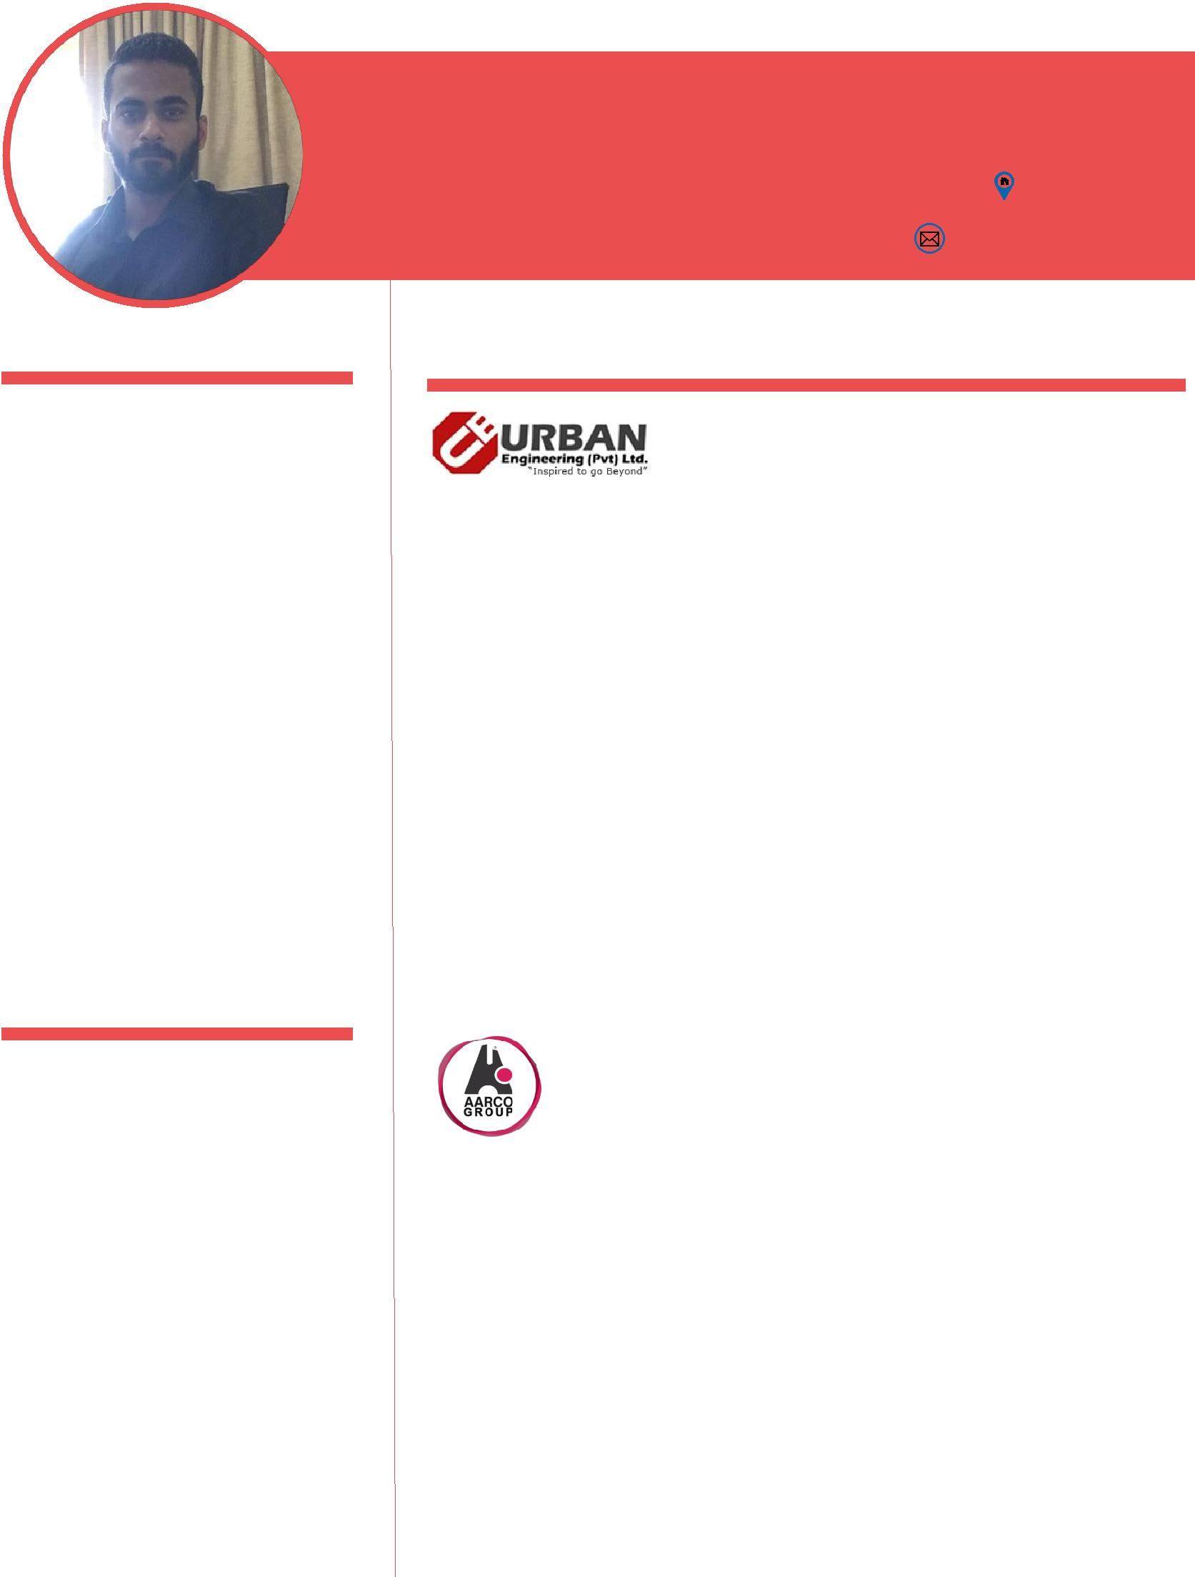
BTEC QUANTITY SURVEYOR

Sharjah – UAE

Email:
Amjedh.374540@2freemail.com

EXPERIENCE

Urban Engineering (Pvt.) Ltd - Colombo (Jan 2016 to Oct 2017)
Duration: 21 Months

Project: Proposed New Apartment for OPAL (Pvt) Ltd (10 stories) Designation: Quantity Surveyor / Estimator / Draftsman

Duties & Responsibilities

- Taking off Quantities (AutoCAD and manually).

- Preparation of BOQ’s, Responsible for BOQ Quantity & verifications on project Qs Reports.
- Preparation of monthly interim Payment Application.

- Maintain a schedule of submissions and responses, approvals, inspections and variations.

- Prepare and report the monthly progress.

- Update AutoCAD drawing as per built.

- Design the electrical and plumbing layouts.

- Identify the variation item and prepare the variation order sheet.

- Monitoring of all commercial information relating to project.

Aarco (Pvt.) Ltd - Colombo (Oct 2014 to Dec 2015)

Duration: 14 Months
Project: Proposed New Apartment for STN STAR Property

Developers (Pvt.) Ltd.

Designation: Quantity Surveyor / Draftsman

Duties & Responsibilities

- Taking off Quantities (AutoCAD and manually).

- Preparation of BOQ’s.

- Prepare Tender and Contract Documents.
- Layout Design.
- Prepar1ation design as per client requirement.

- Responsible for the modification of drawing according to new layout from the client.
- Tendering, negotiating and appointing sub-contractors.

- Site visiting for inspections.

(Mar 2014 to Sep 2014)
Sierra Construction LTD – Beruwala

Duration: 06 Months

Project: Riverina Resorts Construction 5 Star Hotel Project for Riverina Resort (Pvt) Ltd Designation: Trainee Quantity Surveyor / Site Supervisor

Duties

- Referring drawings and supervising as per the drawing.

- Preparing measurement sheet.
- Site Supervising.

PROFESSIONAL QUALIFICATION
- BTEC Higher National Diploma in Quantity Surveying & construction Economics - 2013
  - British College Applied studies (BCAS) Campus, Accredited by the Edexcel by the UK.

- Quantity Surveying – 2015

  - CADD Centre Lanka – Sri Lanka

- MEP Quantity Surveying – 2016
  - CADD Centre Lanka – Sri Lanka

COMPUTER AND TECHNICAL SKILLS
- Sound skill in use of MS Office (Word and Excel, Project).

- Sound Skills in use of AutoCAD 2D, 3D & SketchUp.

- Well knowledge to access of Internet, E-mail & Computerized Processes.

- Good Experience in Layout cum Interior Designing.

- Experience in the following: Quantity take-off, project estimation and tendering billing, cost analysis reports, billing and variations.

DECLARATION

I hereby declare that the above particulars furnished by me are true and correct to the best of my skills and knowledge.

Amjedh Date: 14th of October 2017

