Zaheer
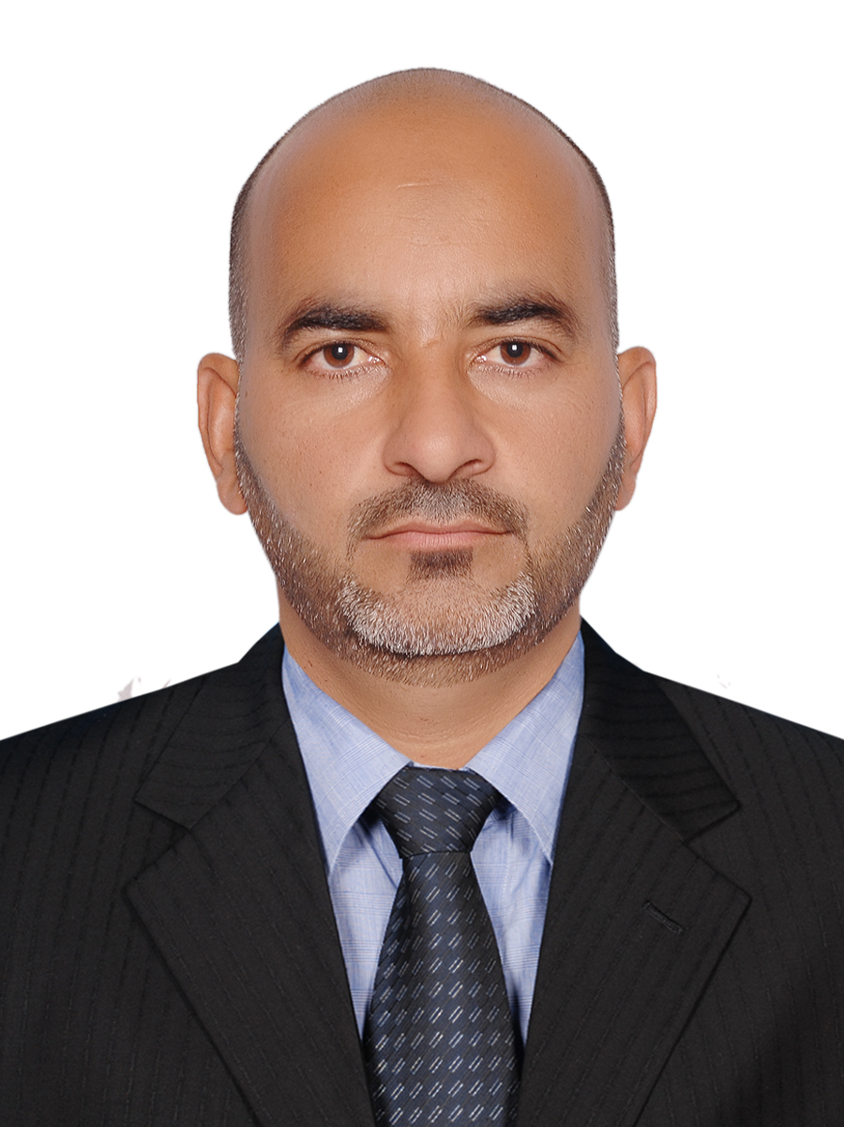

Land Surveyor
Dubai UAE
Email- zaheer.374562@2freemail.com
Name | : | Zaheer  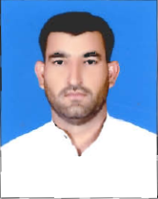
Date of Birth | : | 01.01.1978
Nationality | : | Pakistani
Visa Status | : | Visit Visa
Educational Qualifications | : | Diploma in surveyor, Islamabad, Pakistan
Training / Certificates | : | H2s
Total Yrs of Work Exp. | : | 11 yrs

SNAPSHOTS OF CAREER EXPERIENCE: (starting from AJES)
Name of Company | : | Al Jaber Energy Services, LLC, Abu Dhabi, UAE
Designation | : | Land Surveyor
Date of Employment | : | Sep 2013 to April 2016
Name of Project(s) | : | Zakum Field Facilities Early Civil Works for South ,North, Central & West Islands Abu Dhabi
Duration of Project | : | Expected 3 years
Name of Client | : | Zadco
Job Responsibilities | : | Surveying work

Responsible of Roads works, Vibro Compactions works, Drilling Shelters, Retaining Walls, buildings, Strom water line, Underground utilities, Future Ducts, Potable Thank Piles, diesel Tanks Pile, Fire Water Raw Water Piles, Treated Water Piles all kind internal and external road works and Preparation Of As Built.

SNAPSHOTS OF CAREER EXPERIENCE: (starting from AJES)
Name of Company | : | Al Jaber Energy Services, LLC, Abu Dhabi, UAE
Designation | : | Land Surveyor
Date of Employment | : | oct 2010 to Sep 2013
Name of Project | : | RUWAIS REFINERY AND EXPANSION Project Abu Dhabi
Value of Project | : | Takreer. Client SK
Duration of Project | : | Ruwais Refinery Extension 2
Name of Client | : | Takreer
Job Responsibilities | : | Surveying work
- 11years professional experience of Land Surveyor all kind of Survey works.
- (since 2013 with Zadco Upper Zakum offshore Project as subcontractor
ECW & EPC-1 Project Overall survey works
- (Including 3 years with SK as subcontractor Ruwais Refinery Extension 2
Flow section tanks fire water tanks, huge pipe racks & underground services.
- Establishment of control point, Bench Marks with Static Survey Local Survey.
- Ability to calculate close Traverse and Bench mark both by Manual and by instrument.
- Ability to calculate the coordinate all types of curves and super elevation both by manual and by Total Station.
- Ability to do the Topography survey all type of setting out vertical alignment and contour survey by Total Station.
- Ability to quickly adapt complex corporate environments and to maintain high quality standards of performance in time and cost constraints.
- Ability to establish and maintain professional relationships with clients, colleagues and external bodies.
- Handling the all kinds of Survey works. Related to construction & office works all types of calculations like Closed and Loop traverse with polygonal system, earth works, Orientation of buildings, Administration’s Facilities, calculation of coordinates. Also handled 6 Nos. Remote Degassing Stations with Central Degassing Station, monitoring all the Survey activities in Wellheads, Preparing and arranging daily progress reports, preparing as built drawings, keeping updated Drawings, distribution of Drawings for site surveyor and meeting with clients.
SNAPSHOTS OF CAREER EXPERIENCE: (Guris Dubai
Name of Company |  | GURIS, Dubai, UAE
Designation | : | Surveyor
Date of Employment | : | 2008-2010
Name of Project | : | DS- 174, Main Irrigation Lines, Nad Al-Sheba 3, Dubai
Duration of Project | : | 2 years
Name of Client |  | ACE International Dubai/ Dubai Municipality
Job Responsibilities | : | Surveying work
- Surveying of sewerage & drainage, network & NDRC daily activities as per approved method statement.
- Setting out pipe laying (GRP, UPVC, AC, PVC), concert work construction of new service & road reinstatement.
- Before pipe laying check everything as per client’s requirements
- Construction of chamber
- Shot piece fixing
- House connections
- Air test, Pressure test and Water test
- Pipes Dia, 200mm up to 1200mm Pipes (GRP,PVC,UPVC,ARC)
SNAPSHOTS OF CAREER EXPERIENCE: (Guris Dubia)
Name of Company | : | GURIS, Dubai, UAE
Designation | : | Surveyor
Date of Employment | : | 2007-2008
Name of Project | : | DS- 172/2, Sewerage & Draining Lines, Mirdif, Dubai
Duration of Project | : | 1 year
Name of Client | : | Khatib Almi, Dubai, UAE / Dubai Municipality
Job Responsibilities | : | Surveying work
- Surveying of sewerage & drainage, network & NDRC daily activities as per approved method statement.
- Setting out pipe laying (GRP, UPVC, AC, PVC), concert work construction of new service & road reinstatement.
- Before pipe laying check everything as per client’s requirements
- Construction of chamber
- Shot piece fixing
- House connections
- Air test, Pressure test and Water test
- Pipes Dia, 200mm up to 1200mm
- Pipes (GRP, PVC, UPVC, ARC)
- Ability to establish and maintain professional relationships with clients, colleagues and external

SNAPSHOTS OF CAREER EXPERIENCE: (Guris Dubia)
Name of Company | : | GURIS, Dubai, UAE
Designation | : | Surveyor
Date of Employment | : | 2005-2007
Name of Project(s) | : | DS- 131, Sewerage & Draining Lines, Al Barsha-2,Dubai
Duration of Project | : | 3 years
Name of Client | : | Al Turath, Dubai, UAE / Dubai Municipality
Job Responsibilities | : | Surveying work
- Surveying of sewerage & drainage, network & NDRC daily activities as per approved method statement.
- Setting out pipe laying (GRP, UPVC, AC, PVC), concert work construction of new service & road reinstatement.
- Before pipe laying check everything as per client’s requirements
- Construction of chamber
- Shot piece fixing
- House connections
- Air test, Pressure test and Water test
- Pipes Dia, 200mm up to 1200mm
- Pipes (GRP,PVC,UPVC,ARC)
SNAPSHOTS OF Computer Skills
- MS Office 2003, 2007 (Including Excel, Word, PowerPoint, Access etc.)
- AutoCAD 2010 AutoCAD
- Lieca Geo Office Sokkia Modern

SNAPSHOTS of Survey Equipment
- Total Stations Set 2C, 3C, 2010, 230RK ,2030,510 etc. (Data Rec. & Processing
- Leica Total Stations including Leica Builder, TPS 1205, 805, 1102 &
- RTK GPS and Handled GPS
- Nikon Total Stations
- Topcon Instruments

