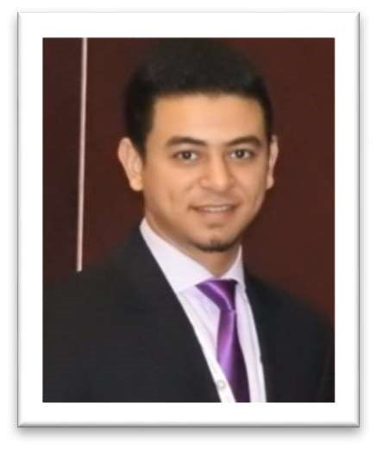
Name: Luay

Email: Luay.374564@2freemail.com

EDUCATION AND QUALIFICATIONS:
- B.S in Biomedical Engineering Ajman University of Science & Technology 2013-2017.
- Internship at Leader Healthcare and Mediclinic City Hospital June to august 2017.
- High School - Al Rashid Al Saleh Privet School, Dubai 2009-2013.

SKILLS:
- Languages:
- Arabic (Native)
- English (IELTS Score 6.0)
- Microsoft Office.
- MATLAB, SAP, MicroC, C++, Arduino IDE, AutoCAD, Adobe Photoshop.
- Analysis of computer hardware and software.
- Driving license with an available car.

WORK EXPERIENCE:

- Leader Healthcare & Mediclinic City Hospital:
- Duration: June 2017 to August 2017.
- Description: I had my internship in Leader healthcare and Mediclinic City Hospital to obtain experience of both work fields, I also had a technical training on CareFusion 3100a HFOV and SLE3600 INOSYS by Virtus Co. as well as Evita V300 and BABYLOG VN500 ventilators by DRAGER, it was an amazing experience to get involved in the field.

- Ajman University:
- Duration: September 2016 to April 2017.
- Description: As a supervision in medical electronics lab, microcontroller and microprocessor lab and general lab supervision responsibilities (assisting students in conducting experiments and providing them the needed components).
This developed my skills in taking responsibilities and managing the workstations, it also increased my knowledge in regards of lab equipment.

References: Upon Request.

