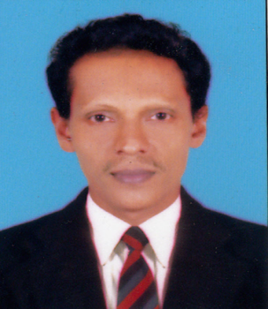
SIDEEQUE
Sideequeu.374572@2freemail.com
Core Competency

5.6 Years of experience in Administration & Training Field
Bachelor Degree in Economics
Good communication skills, adaptability & understanding of Insurance and administration functions.
CAREER OBJECTIVE
To work in a challenging and conducive atmosphere which emphasizes my skill and to continuously learn and grow amidst new challenges where my efficiency and efforts can be utilized for the benefit of the company
PROFESSIONAL EXPERIENCES

Organization | ICICI Prudential Co.
Duration | 2008 to 2015
Designation | Administrator cum Trainer
Company Profile | ICICI Prudential Life insurance company is one of the largest insurance company in India. Company also established in general insurance sector
Job Profile | - Support day to day administrative activities  - Coordinating with Head office and sending instruction to bank  - Give support to the customers for speedy settlement of claim  - Advise customer for all claim before submit the documents  - Review the insurance documents and final check before going to login the policy  - Coordinate with regional office in order to speed up claim and services  - Preparing Training Materials and documents  - Providing detailed training to Advisors as and when required  - Introduce new products and its benefits  - Help advisors for online exam of IRDA  - Make all the arrangements in the training hall to conduct training  - Work with other departments to ensure for timely and accurate information

Organization | Akshaya IT Program Malappuram-Kerala
Duration | March 2003 to April 2006
Designation | Administrator cum Accountant
Company Profile | Semi Government undertaking center provides IT related services to the public
Proficiency In Specific Jobs | - Coordinate with local Akshaya center within the region  - Responsible of all Office Related Work.  - Preparing the payment report.  - Preparing and typing Business letters, Quotations  - Trouble shooting computer  - Work with other departments to ensure timely and accurate information.  - Assist in the preparation of yearend audit files and analysis  - Other relevant works associated with Book Keeping  - Maintaining files  - Maintain office supplies inventories.  - Performs variety of clerical duties.  - Providing General Government service Like Electricity and Telephone Payment
n
EDUCATIONAL QUALIFICATION

- Bachelor Degree in Economics
- Diploma in Front Office Operation
- Diploma in Computer Education
- National Certification in Financial Market (NCFM)

Awards during My Carrier with ICICI Prudential
- Certificate of Excellence (IRDA Pass percentage)
- Rank One in Palakkad cluster for Super Sprint.
- Rank Two in Palakkad cluster for WRP…………..,
- 2009-2010-Recognition from Team Kerala for Super Sprint

- Self-confident, self-disciplined and diligent person.
STRENGTHS:
- Human relation attitude, leadership & foresight skills.
- Straight forward & digital nature.
- Honesty & positive thinker with optimistic & practical approach towards problems.

Computer Languages | Ms Office & Good Typing Skills
PERSONAL DETAILS

Date of Birth | 15/05/1970
Languages Known | English, Hindi, Malayalam
Visa Status | Visit Visa
Sex | Male
Religion | Islam, Muslim

Declaration

I hereby declare that all the information furnished above is true to the best of my knowledge

Yours faithfully

