MIT Center For Management Studies and Research, Pune
Amit  Emai ld: Amit.374574@2freemail.com  Course: MBA (Operations)  Date of Birth: 28-11-1988 | Marital Status: Unmarried  Language Known: English, Hindi & Marathi | 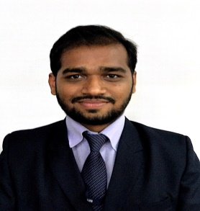

Educational Qualifications:
Education | Year of Passing | University /Board | Major Subjects | SGPA
M.B.A. | 2016-18  Pursuing | Savitribai Phule Pune University | Operations | 7.960(1st Sem)  7.380(2nd Sem)
B.E | 2011 | Pune University | Printing Engineering | 67.33%
H.S.C. | 2007 | Maharashtra State Board | Science | 68%
S.S.C. | 2004 | Maharashtra State Board |  | 83.46%

Professional Details:
Organization Name | Designation | Description of Job | Duration
Kimoha Entrepreneurs Ltd. Dubai | Digital Print Incharge | Responsible for Daily Production | 2 Years 10 Months
Webtech Labels  Mumbai | Production Supervisor | Responsible for product Quality | 1 Year 1 Month

Industry Internship:
Organization Name | Title of Project | Period | Key Learning Outcomes
Varroc Engg. Pvt. Ltd. Pune. | Establishing Standards for material master data management | 2 Months | Acquired knowledge about different materials, learned their characteristics, uses, and actual industrial application, design product description and nomenclature standards along with unique codification and identification acc to UNSPSC which help in procurement decision making.
Certifications:
- SIX SIGMA GREEN BELT
- ADVANCE EXCEL

Computer Proficiency:
- MS Office
- Operating System: Windows
- Desktop Publishing

Co-Curricular Activities:
- Director-Operations Club, MITCOE CMSR
- Won IADR Presentation Competition held at MITCOE
- Participation in International 24 hr Innovation Competition organized by NTA University, Spain.

Achievements:
- Won first prize globally in digitally printed label (Dry Toner Category) in FINAT Label Competition 2015, The Hague (Netherlands)
- Won first prize (Star of the month award) for producing INNOVATIVE LABEL.

Declaration:
I hereby declare that the above mentioned information is correct and true to the best of my knowledge.

Place: Pune
Date:

