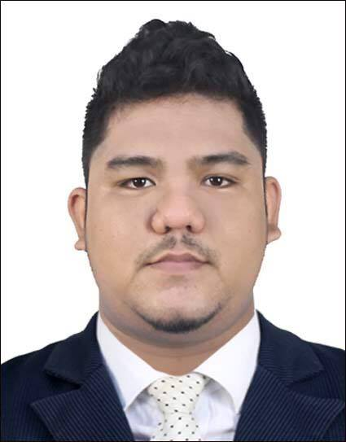
Hester

Professional Profile and Objective

I am a certified Aviation Maintenance Technician ( Airframe and Powerplant Rated ) duly licensed by the Civil Aviation Authority of the Philippines (CAAP) - License Number

I have successfully completed Airside Safety Course by the International Air Transport Association
( IATA ), IOSH Managing Safely by the Institute of Occupational Safety and Health and currently taking the NEBOSH International General Certificate ( IGC ) by the National Examination Board in Occupational Safety and Health.

I am looking for a competitive position in the company where I can use my knowledge in Aircraft Maintenance, Aviation Safety, Occupational Safety & Health and my diverse technical skills and background to enhance the company’s goals and objectives and to develop my career.

Academic Background

Bachelor of Science in Aircraft Maintenance Technology ( BSAMT )
Philippine State College of Aeronautics Mactan Campus
Mactan Benito Ebuen Air Base, Lapu-Lapu City, Cebu, Philippines
Year 2011 – 2015

Extra Curricular

Air Police Officer – Reserved Officers Training Course
Armed Forces of the Philippines ( AFP )
PAF 5th Air Force Reserved Command – Philippine Air Force

Professional Affiliation

INSTITUTE OF OCCUPATIONAL SAFETY & HEALTH ( IOSH )
The Grange, Highfield Drive Wigston, Leicestershire, LE18 1NN, United Kingdom

Work Experience

MIASCOR AVIATION CEBU HUB
Mactan Cebu International Airport
Line Maintenance Technician
May 17,2015 – June 20,2016
Duties and Responsibilities

- Look after my own safety and the safety of others when carrying out maintenance tasks.
- Performing Routine and Non-Routine Maintenance of Aircrafts such as Airbus - A320, A321.
A330-300 registered at different countries.
- Performing Aircraft Servicing such as Ground Power Unit ( GPU ) Auxlliary Power Unit ( APU ).
- Nitrogen filling of the MLG Two-stage shock absorber.
- Wheel, Tire and Brake Check/Replacement.
- Inspect completed work to certify that maintenance meets standards.

Apprenticeship

MIASCOR AVIATION CEBU HUB April 14,2014 – May 4,2015
Mactan Cebu International Airport
Aircraft Line Maintenance
Aircraft Handled : A320 /A321 / A330-300

Training Programs and Seminars Attended

NEBOSH INTERNATIONAL GENERAL CERTIFICATE ( IGC )
National Examination Board in Occupational Safety & Health
QHSE International, Opal Tower
Burj Khalifa Boulevard, United Arab Emirates

IOSH MANAGING SAFELY November 3,2017
Institute of Occupational Safety & Health
QHSE International, Opal Tower
Burj Khalifa Boulevard, United Arab Emirates

IATA BASIC AIRSIDE SAFETY March 7,2017
International Aviation Transportation Association
Sharaf Aviation Services Academy
Bur Dubai, United Arab Emirates

RAMP SAFETY SEMINAR January 19,2015
AVR – Aeronautical Engineering Department
Philippine State College of Aeronautics
Mactan Benito Ebuen Air Base
Lapu-Lapu City, Cebu, Philippines

AIRBUS 320 GENERAL FAMILIARISATION November 19,2014
AVR – Aeronautical Engineering Department
Philippine State College of Aeronautics
Mactan Benito Ebuen Air Base
Lapu-Lapu City, Cebu, Philippines

Knowledge, Skills and Abilities

Knowledge

- Aircraft Line Maintenance
- Airline Operation ( Groundhandling and Aircraft Servicing )
- Proven knowledge in Airside Safety & Occupational Safety & Health
- Health and Safety Management System ( HSMS ) ILO – OSH 2001, OHSAS 18001
- International Labor Organization ( ILO ) Occupational Safety and Health Recommendation
- ( R164 Article 10 ) Obligations of the Employer and duties of the Employees.
- Risk Assessment, Eliminating & Reducing Hazards and Risks
- Types of Chemicals and Harmful Substances
- Globally Harmonized System ( GHS ) and Labelling of Chemicals
- Fire Safety, Categories of Fire and Fire Suppression
- First Aid & Emergency Response

Skills

- Strong interpersonal
- Excellent English communication and Training Skills
- Carryout Risk Assessment, Hazard Identification and Reduction
- Incidents & Accidents Investigation
- Able to conduct basic Safety Trainings and refresh the skills of your current staff
- Able to provide common knowledge base to all staff to cooperate safely and respond to incidents and accidents, Detail-oriented, organized, and positive attitude
- Carryout maintenance according to manufacturers standards and the company’s standards.
- Highly motivated and capable of working under pressure and time constraints
- Proficient in playing various musical instruments (e.g. Saxophone, Drums, Guitar, Violin, Flute, Bass Guitar) part time Musical Director of a Filipino community Symphony Orchestra group in the United Arab Emirates.
- Computer literate, MS Office
- Light vehicle driving

Personal Attributes

- Honest, trustworthy and flexible
- Possess cultural awareness and sensitivity
- Demonstrate sound work ethics
- Straight forward

Character Reference – Available upon request

